



**Module Code & Module Title**

**CS6PO5NT-Final Year Project**

**Assessment Weightage & Type**

**Final Year Project Proposal (5%)**

**Year and Semester**

**2023-24 Spring**

**Student Name: Aasmee Rai**

**London Met ID: 22072035**

**College ID: NP05CP4A220006**

**Assignment Submission Date: April 30, 2025**

**Internal Supervisor: Sonam Rai**

**External Supervisor: Utsav Dhungana**

**Title: Ingreedy (Smart Recipe App)**

*I confirm that I understand my coursework needs to be submitted online via Google Classroom under the relevant module page before the deadline for my assignment to be accepted and marked. I am fully aware that late submissions will be treated as non-submission and a mark of zero will be awarded*

# Abstract

The "Ingreedy" project proposes an innovative solution to the challenges of meal preparation and pantry management through the development of a Smart Recipe Finder application. Leveraging advanced technologies such as artificial intelligence (AI) for ingredient recognition and personalized recipe recommendations, the app addresses issues like food waste, inefficient grocery planning, and dietary accommodations. Key features include AI-powered ingredient recognition via OCR and barcode scanning, automated pantry management with expiry tracking and inventory alerts, and a personalized recipe generator that aligns with user preferences and available ingredients.

The app also fosters community engagement through a recipe-sharing platform. Designed with user-friendliness, sustainability, and inclusivity in mind, "Ingreedy" enhances the cooking experience while promoting efficient ingredient usage. By incorporating a Scrum-based agile methodology, the project ensures iterative development and stakeholder feedback to achieve a functional and user-centric application. This project aims to redefine cooking and pantry management, making meal preparation an efficient, enjoyable, and resourceful process

Table of Contents

Abstract i

Chapter 1: Introduction 1

1.1. Introduction to the topic 1

1.2. Problem Statement 1

1.3. Project as a Solution 2

1.4. Aims and Objectives 3

Chapter 2: Background 4

2.1. About client/end user 4

2.2. Understanding the solution 4

2.3. Similar projects 4

2.4. Comparisons between similarity of the systems 6

Chapter 3: Development 7

3.1. Approach / Methodology Considerations 7

3.2. Stages of chosen Approach / Methodology 8

3.3. Survey Results 10

3.3.1. Pre-Survey Results 10

3.3.2. Post-Survey Results 10

3.4. Requirement Analysis 11

3.4.1. SRS 11

3.5. Designs 13

3.5.1. Work Breakdown Structure 13

3.5.2. Entity Relation Diagram 14

3.5.3. Data Flow Diagram (DFD) 20

3.5.4. Use Case Diagrams 20

3.5.5. High-level Expanded Use Case Diagram 21

3.5.6. Flowchart 29

3.6. Implementation 30

3.6.1. Database 30

3.6.2. Code Implementation 39

Chapter 4: Testing and Analysis 44

4.1. Test Plan 44

4.2. System Testing 44

4.2.1. Authentication Testing 45

4.3. API testing 3

4.3.1. Register 15

4.3.2. Login 16

4.3.3. Make post 17

4.3.4. Get post 18

4.3.5. Delete post 19

4.3.6. Update posts 20

4.3.7. Like post 21

4.3.8. Bookmark posts 22

4.3.9. View bookmarked posts 23

4.3.10. Get single post 24

4.3.11. Add comment 25

4.3.12. Get comment 26

4.3.13. Delete comment 27

4.3.14. Edit comment 28

4.3.15. Get notification 29

4.3.16. Read notifications 30

4.3.17. Add items to Shopping List 31

4.3.18. Get shopping list 32

4.3.19. Update list 33

4.3.20. Delete list item 34

4.3.21. Get all recipes 35

4.3.22. Get a single recipe 36

4.3.23. Save search tags 37

4.3.24. Get profile 38

Chapter 5: Conclusion 39

5.1. Advantages 39

5.2. Limitations 39

Chapter 6: Future Work 40

Chapter 7: References 41

Chapter 8: Appendix 43

8.1. Appendix A: Pre-Survey 43

8.1.1. Pre-Survey Form 43

8.1.2. Sample of Filled Pre-Survey Forms 48

8.1.3. Pre-Survey Result 52

8.2. Appendix B: Post-Survey 57

8.2.1. Post-Survey Form 57

8.2.2. Sample of Filled Post-Survey Forms 60

8.2.3. Post-Survey Result 63

8.3. Appendix C: Sample Codes 67

8.3.1. Sample Code of The UI 67

8.4. Appendix D: Designs 68

8.4.1. Gantt Chart 68

8.4.2. Work Breakdown Structure 69

8.4.3. Flowcharts 69

8.4.4. Data Flow Diagrams 69

8.4.5. Use Case 70

8.4.6. Wireframe 71

8.5. Appendix E: Screenshots of The System 84

Table of Figures

Figure 1: Scrum Methodology 9

Figure 2: Total reponses accumulated in pre-survey form 10

Figure 3: Enitiy Relationship Diagram 14

Figure 4: Collaboration diagram of “Manage Pantry” 22

Figure 5: Sequence diagram of “Manage Pantry” 22

Figure 6: Collaboration diagram of “Search Recipe” 23

Figure 7: Sequence diagram for “Search Recipe” 24

Figure 8: Collaboration of “Make Shopping List” 25

Figure 9: Sequence diagram for “Make Shopping List” 26

Figure 10: Collaboration of “Make Post” 27

Figure 11: Sequence diagram for “Make Post” 28

Figure 12: Database Structure 30

Figure 13: Registering new user 45

Figure 14: Login page 45

Figure 15: Entering login credentials 1

Figure 16: Home page 1

Figure 17: Adding item to pantry 1

Figure 18: Succession message 1

Figure 19: Creating a new post 1

Figure 20: New post in home page 1

Figure 21: Comments box 1

Figure 22: New comment added 1

Figure 23: Register API testing 15

Figure 24: Login API testing 16

Figure 25: Post creation API testing 17

Figure 26: Get post API testing 18

Figure 27: Deleting post API testing 19

Figure 28: Updating posts API testing 20

Figure 29: Liking post API testing 21

Figure 30: Bookmarking posts API testing 22

Figure 31: View bookmarked posts API testing 23

Figure 32: Adding items to list API testing 31

Figure 33: Get shopping list of the active user API testing 32

Figure 34: Update shopping list item API testing 33

Figure 35: Deleting list item API testing 34

Figure 36: Get all recipes API testing 35

Figure 37: Get a single recipe by id API testing 36

Figure 38: Save tags from the user’s search API testing 37

Figure 39: Get user profile API testing 38

Figure 40: Pre-Survey Form pt.1 43

Figure 41: Pre-Survey Form pt.2 44

Figure 42: Pre-Survey Form pt.3 45

Figure 43: Pre-Survey Form pt.4 46

Figure 44: Pre-Survey Form pt.5 47

Figure 45: Filled Pre-Survey Form Sample pt.1 48

Figure 46: Filled Pre-Survey Form Sample pt.2 49

Figure 47: Filled Pre-Survey Form Sample pt.3 49

Figure 48: Filled Pre-Survey Form Sample pt.4 50

Figure 49: Filled Pre-Survey Form Sample pt.5 51

Figure 50: Filled Pre-Survey Form Sample pt.6 51

Figure 51: Pre-Survey Q1 52

Figure 52: Pre-Surgery Q2 52

Figure 53: Pre-Survey Q3 53

Figure 54: Pre-Survey Q4 53

Figure 55:Pre-Survey Q5 54

Figure 56: Pre-Survey Q6 54

Figure 57: Pre-Survey Q7 55

Figure 58: Pre-Survey Q8 55

Figure 59: Pre-Survey Q9 55

Figure 60: Pre-Survey Q10 56

Figure 61: Pre-Survey Q11 56

Figure 62: Post Survey Form pt.1 57

Figure 63: Post-Survey Form pt.2 58

Figure 64: Post-Survey Form pt.3 59

Figure 65: Post-Survey Form pt.4 59

Figure 66: Post-Survey Smaple Form pt.1 60

Figure 67: Post-Survey Sample Form pt.2 61

Figure 68: Post-Survey Sample Form pt.3 61

Figure 69: Post-Survey Sample Form pt.4 62

Figure 70:Post-Survey Q1 63

Figure 71: Post-Survey Q2 63

Figure 72: Post-Survey Q3 64

Figure 73: Post-Survey Q4 64

Figure 74: Post-Survey Q5 65

Figure 75: Post-Survey Q6 65

Figure 76: PosT-Survey Q7 66

Figure 77: Gantt Chart 68

Figure 78: Work Break Structure 69

Figure 79: Data Flow Diagram 69

Figure 80: Use case diagram 70

Figure 81: Register Page Wireframe 71

Figure 82: Login Page Wireframe 72

Figure 83: Home Page Wireframe 73

Figure 84: Recipe Page Wireframe 74

Figure 85: Scan result wireframe 75

Figure 86: Recipe details wireframe 76

Figure 87: Create Post Wireframe 77

Figure 88: Pantry Page Wireframe 78

Figure 89: Add ingredient wireframe 79

Figure 90: Saved recipes screen wireframe 81

Figure 91: Profile Page Wireframe 82

Figure 92: Login page screenshot 84

Figure 93: Register page screenshot 85

Figure 94: Home page screenshot 86

Figure 95: List page screenshot 87

Figure 96: Recipes page screenshot 88

Figure 97: Create Post page screenshot 89

Figure 98: Pantry page screenshot 90

Figure 99: Profile page screenshot 91

Table of Tables

Table 1: Similarity comparison 6

Table 2: Registration test case 45

Table 3: Login test case 1

Table 4: Adding pantry item test case 1

Table 5: Creating post test case 2

Table 6: Making comment test case 1

Table of Abbreviations

|  |  |
| --- | --- |
| Abbreviations | Full Form |
| AI | Artificial Intelligence |
| OCR | Optical Character Recognition |
| DFD | Data Flow Diagram |
| ERD | Entity Relationship Diagram |
| SRS | Software Requirement Specification |
| WBS | Work Breakdown Structure |
| UI | User Interface |
|  |  |
|  |  |

# Introduction

## Introduction to the topic

Ingreedy (Smart Recipe Finder) transforms meal preparation with innovative features like AI-powered ingredient recognition, personalized recipe suggestions, pantry tracking, and automatic shopping list generation. The app helps users make the most of their ingredients, explore recipes tailored to their dietary preferences, and plan meals efficiently.

Beyond its practical benefits, Ingreedy fosters creativity by encouraging users to try new recipes and reduce food waste. Its interactive community forum allows users to share tips, post recipes, and connect with like-minded cooking enthusiasts. Designed for convenience, sustainability, and inclusivity, Ingreedy ensures cooking is an enjoyable and resourceful experience for users of all skill levels.

## Problem Statement

In today’s fast-paced lifestyle, meal preparation often becomes a challenging task for individuals, families, and even professional cooks. A common problem is the inefficient use of available ingredients, leading to food waste and missed opportunities to create meals from what’s already in the pantry. (Porter & Reay, 2015) People often find it time-consuming and tedious to plan meals, especially when trying to accommodate dietary restrictions, nutritional goals, or personal preferences. (Huff, 2022)

Another significant issue is the lack of tools to manage pantry inventory effectively. Ingredients may expire or run out unnoticed, causing disruptions in meal planning and unnecessary trips to the grocery store. (THE OWL, 2024) The abundance of online recipes can overwhelm users, making it hard to find ones that suit their tastes or needs. Additionally, there's a growing demand for community and inspiration in cooking, highlighting a gap for an all-in-one kitchen management and recipe discovery tool.

## Project as a Solution

The Ingreedy (Smart Recipe Finder) simplifies cooking and pantry management with a user-friendly platform powered by AI. By using photos or barcode scans, users can quickly digitize their pantry contents, enabling the app to suggest recipes based on the ingredients they already have. This feature helps reduce food waste, save time, and make meal preparation more efficient.

In addition to recipe suggestions, Ingreedy tracks ingredient quantities, monitors expiry dates, and sends timely alerts for low-stock or near-expiry items, helping users stay organized and plan meals effectively. The app also generates shopping lists for missing ingredients and allows users to customize recommendations based on dietary preferences or nutritional goals, ensuring a personalized experience.

Beyond practicality, Ingreedy fosters a sense of community through a recipe-sharing forum where users can exchange ideas, discover new techniques, and explore diverse cuisines. With multilingual support, the app is accessible to a global audience, transforming cooking into a creative, efficient, and enjoyable activity for users around the world.

## Aims and Objectives

**Aim:**

To reduce food waste by enabling users to utilize existing pantry ingredients through intelligent recipe suggestions.

**Objectives:**

* Develop a pantry management module that allows users to track ingredient quantities and receive alerts for items nearing expiration.
* Enable personalized recipe filtering.
* Create shopping lists.
* Design an intuitive user interface that encourages frequent use of the pantry feature and simplifies meal planning.
* Provide a “Surprise Me” feature that uses AI to suggest creative recipes using leftover or rarely used ingredients.
* Community forums for users to interact.

# Background

## About client/end user

The end users for the "Ingreedy" app are individuals or families looking to simplify their cooking and pantry management processes. This includes users with dietary restrictions, culinary enthusiasts, or people aiming to reduce food waste. The app is also designed for a global audience with multilingual support to ensure inclusivity.

## Understanding the solution

The app leverages AI-powered OCR for ingredient recognition, personalized recipe recommendations, and efficient pantry management. It integrates advanced technology to automate inventory tracking, provide dietary customization, and generate automated shopping lists. Additionally, the app fosters a community environment where users can share recipes and engage with others.

## Similar projects

Several projects and applications like Ingreedy have been developed in the past, each addressing various aspects of meal preparation and pantry management. Below is a concise review of some noteworthy examples.

1. **Yummly**

* The Yummly app is a smart cooking companion, offering personalized recipe recommendations tailored to your tastes, dietary preferences, and allergies. With features like ingredient-based searches to reduce food waste, quick recipe filters, a digital cookbook for saving favorites, and step-by-step guided cooking, Yummly makes mealtime effortless. Its smart shopping list and meal planning tools streamline your grocery trips and daily schedules, while Yummly Premium unlocks guided videos, nutritional insights, and advanced planning options. Whether you're exploring new cuisines or optimizing leftovers, Yummly simplifies cooking for every lifestyle. (Aptoide, 2025)

1. **Tasty**

* Tasty is a comprehensive cooking platform offering over 10,000 recipes, combining detailed instructions with video content and personalized recommendations. Its AI assistant, Botatouille, uses user preferences to suggest recipes, encouraging exploration of diverse culinary options. The platform integrates with Walmart, allowing users to shop for ingredients and arrange delivery or pickup directly through the app. Tasty also fosters a community-driven experience, enabling users to share recipes, gain inspiration, and exchange cooking knowledge. Additional features include custom recipe collections, an ingredient-based search function, adjustable serving sizes, and insights from creators and community feedback, making it a versatile tool for home cooks. (Sensor Tower, 2025)

1. **Cookpad**

* Cookpad is a global platform for recipes and meal planning, showcasing home-cook-created dishes with clear, step-by-step instructions. Users can search for recipes by ingredients to reduce food waste, organize them into custom collections, and plan weekly menus. The app also features a vibrant cooking community where users can share recipes, exchange tips, and post photos of their creations. Designed for all skill levels and dietary needs, Cookpad provides inspiration for everything from quick breakfasts to intricate dinners and international cuisine. (Aptoide, 2025)

## Comparisons between similarity of the systems

Table : Similarity comparison

|  |  |  |  |  |
| --- | --- | --- | --- | --- |
| Features | Yummly | Tasty | Cookpad | Ingreedy |
| AI-powered ingredient recognition | No | No | No | Yes |
| Pantry Management | No | No | No | Yes |
| Recipe generation based on pantry items | No | No | No | Yes |
| Profile management | Yes | Minimal | Yes | Yes |
| Community engagement | Yes | No | Yes | Yes |
| Automatic shopping list generation | Yes | No | No | Yes |

# Development

## Approach / Methodology Considerations

For the development of the Smart Recipe Finder App, several development methodologies were carefully evaluated to determine the most suitable approach for the project's needs and objectives. Each methodology presented unique strengths and weaknesses when applied to the dynamic and feature-rich nature of this project.

* **Waterfall**
* Waterfall provided a structured and linear framework, offering clear stages for planning, design, development, and testing. However, its rigid structure proved unsuitable for accommodating evolving requirements and iterative refinements, which are critical for a project of this scope and complexity.
* **Kanban**
* Kanban excelled in tracking workflow and ensuring visibility across tasks, promoting a smooth and efficient process. Despite its strengths in workflow management, it lacked time-boxed iterations, which are essential for managing the complex and interdependent features of the app, such as AI-based ingredient recognition and pantry management.
* **Lean**
* Lean emphasized minimizing waste and maximizing efficiency, aligning well with the goal of delivering value-driven outcomes. However, it fell short in supporting the frequent collaboration, adaptive planning, and iterative refinement necessary for such a dynamic and user-centric project.

By understanding the limitations and benefits of each approach, the team was able to make an informed decision to adopt a methodology that best aligns with the app's goals and ensures successful delivery.

## Stages of chosen Approach / Methodology

After evaluating the Waterfall, Kanban, and Lean methodologies, Scrum was chosen as the most suitable methodology for the development of the "Ingreedy" Smart Recipe Finder app. Scrum's emphasis on flexibility, collaboration, and iterative progress makes it ideal for handling the app's dynamic requirements and complex feature set. Below is a brief description of the key phases in Scrum:

* Product Backlog Creation
* The team identifies and prioritizes all the tasks and features required for the project. These are documented in the Product Backlog, serving as a dynamic to-do list.
* Sprint Planning
* Before each sprint (a time-boxed iteration), the team selects high-priority tasks from the Product Backlog and defines clear goals for that sprint.
* Sprint Execution
* During the sprint, the team works collaboratively to develop the selected features. Daily Scrum meetings are held to discuss progress, address obstacles, and ensure alignment.
* Sprint Review
* At the end of the sprint, the team demonstrates the completed work to stakeholders, gathers feedback, and identifies areas for improvement.
* Sprint Retrospective
* The team reflects on the sprint process to identify successes, challenges, and opportunities for improvement in future iterations.
* Increment Delivery
* Each sprint delivers a functional increment of the app, contributing to the project’s overall progress and ensuring continuous value delivery.

This iterative process ensures that the app evolves based on stakeholder feedback, allowing the team to adapt to changing requirements while maintaining a focus on delivering high-quality features.

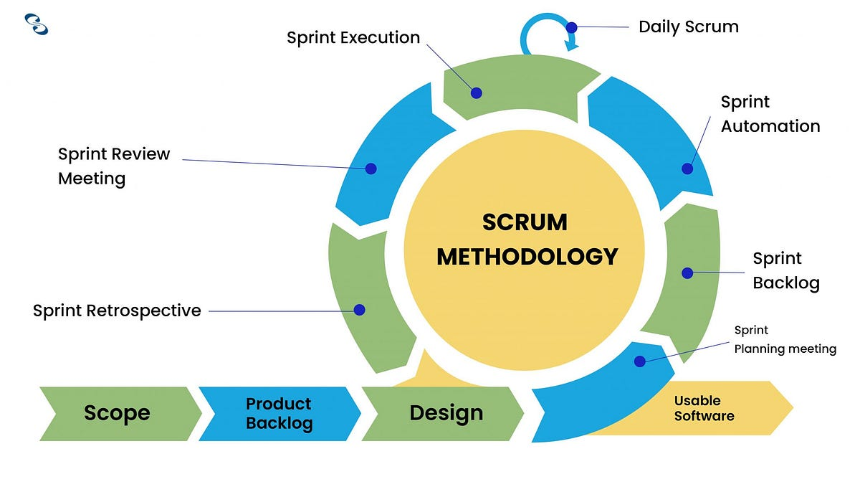

Figure : Scrum Methodology

## Survey Results

### Pre-Survey Results

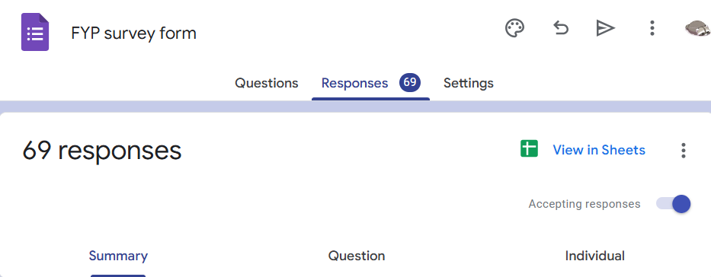

Figure : Total reponses accumulated in pre-survey form

A comprehensive survey was conducted to identify and understand the key challenges and user needs that the project aims to address. The primary objective was to gather insights into common issues faced during meal preparation, pantry management, and recipe selection, ensuring that the final solution effectively responds to real user concerns and expectations.

The findings of the pre-survey can be found in the appendix section.

### Post-Survey Results

The survey was conducted to evaluate users’ experiences with the app, focusing on how intuitive, functional, and satisfying they found it during their interaction with its features. It aimed to gather feedback on usability, performance, and overall satisfaction to identify strengths and areas for improvement. The responses help guide future development and ensure the app better meets user needs and expectations.

The findings of the post-survey can be found in the appendix section.

## Requirement Analysis

### SRS

**Functional requirements**

**Add Ingredients:**

Users can add ingredients manually or via an OCR scanner, and the system will store details such as expiry dates and stock levels. Notifications will be sent for items nearing expiration or running low.

**Search Recipe:**

Users can search for recipes based on available ingredients and apply filters like dietary preferences. The system will display a personalized list of recipe suggestions.

**Make Shopping List:**

Users can generate a shopping list by selecting ingredients that are low in stock or needed for recipes.

**Make Post:**

Users can create and publish posts in the community forum after content validation by the system.

**Non-functional requirements**

1. **Design and Implementation constraints**

The "Ingreedy" application is designed with scalability, security, and usability in mind. The system must handle a growing user base without compromising performance, ensuring smooth functionality even with large datasets of recipes and ingredients. Security protocols like data encryption safeguard user information and pantry details. Additionally, the technology stack integrates AI for OCR and barcode scanning, ensuring seamless ingredient recognition and inventory management.

1. **External interfaces required:**

**User interfaces**

* The app provides an intuitive, mobile-friendly interface that allows users to easily add ingredients, search recipes, manage their pantry, and engage with the community. The design prioritizes accessibility and ease of navigation to cater to users of all skill levels.

**Hardware interfaces**

* Integration with smartphone cameras enables users to scan barcodes and capture images of ingredients for OCR-based recognition. This feature ensures efficient digitization of pantry data, making the app accessible to a wide range of devices.

**Software interfaces**

* The application interacts with APIs for fetching recipe data, cloud storage for managing pantry information, and third-party libraries for OCR and barcode functionality. This modular approach ensures the app's robustness and maintainability.

**Communication interfaces**

* The app requires a stable internet connection to access cloud-based functionalities like inventory synchronization, personalized recipe suggestions, and community forum interactions. It supports real-time data transfer to keep user information up to date across devices.

## Designs

### Work Breakdown Structure

A Work Breakdown Structure (WBS) is a hierarchical framework that breaks down a project into manageable components, providing a clear overview of the project scope and deliverables. It organizes tasks and subtasks in a structured manner, allowing project teams to better plan, allocate resources, and manage risks effectively.

The WBS for this project can be found in the appendix area.

### Entity Relation Diagram

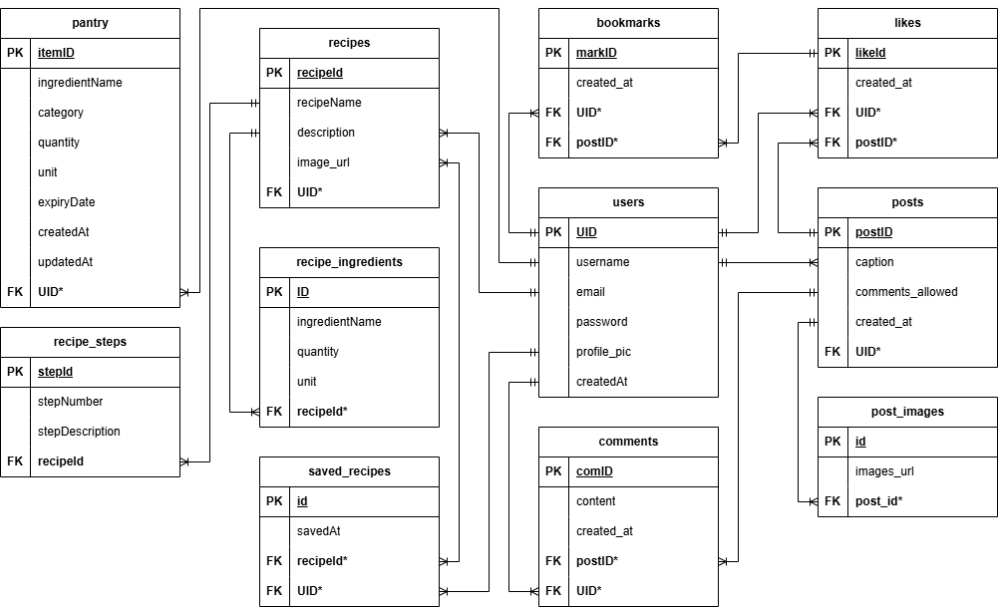

Figure : Enitiy Relationship Diagram

**Entity and their atributes:**

**users**

* + UID (Primary Key)
  + username
  + email
  + password
  + profile_pic
  + createdAt

**posts**

* + postID (Primary Key)
  + UID* (Foreign Key)
  + caption
  + comments_allowed
  + created_at

**post_images**

* + id (Primary Key)
  + post_id* (Foreign Key)
  + image_url

**comments**

* + comID (Primary Key)
  + postID* (Foreign Key)
  + UID* (Foreign Key)
  + content
  + created_at

**likes**

* + likeId (Primary Key)
  + UID* (Foreign Key)
  + postID* (Foreign Key)
  + created_at

**bookmarks**

* + markID (Primary Key)
  + UID* (Foreign Key)
  + postID* (Foreign Key)
  + created_at

**pantry**

* itemID (Primary Key)
* UID* (Foreign Key)
* ingredientName
* category
* quantity
* unit
* expiryDate
* createdAt
* updatedAt

**recipes**

* + recipeId (Primary Key)
  + recipeName
  + description
  + image_url
  + UID* (Foreign Key)

**recipe_ingredients**

* + ID (Primary Key)
  + ingredientName
  + recipeId* (Foreign Key)
  + quantity
  + unit

**recipe_steps**

* + stepId (Primary Key)
  + recipeId* (Foreign Key)
  + stepNumber
  + stepDescription

**saved_recipes**

* + id (Primary Key)
  + recipeId* (Foreign Key)
  + UID* (Foreign Key)
  + savedAt

**Relationship:**

1. Users ↔ Posts

* One-to-Many: A user can create multiple posts.
* users.UID ⟶ posts.UID

1. Posts ↔ Post Images

* One-to-Many: A post can have multiple images.
* posts.postID ⟶ post_images.post_id

1. Posts ↔ Comments

* One-to-Many: A post can have multiple comments.
* posts.postID ⟶ comments.postID

1. Users ↔ Comments

* One-to-Many: A user can write multiple comments.
* users.UID ⟶ comments.UID

1. Posts ↔ Likes

* One-to-Many: A post can have many likes.
* posts.postID ⟶ likes.postID

1. Users ↔ Likes

* One-to-Many: A user can like many posts.
* users.UID ⟶ likes.UID

1. Posts ↔ Bookmarks

* One-to-Many: A post can be bookmarked by many users.
* posts.postID ⟶ bookmarks.postID

1. Users ↔ Bookmarks

* One-to-Many: A user can bookmark many posts.
* users.UID ⟶ bookmarks.UID

1. Users ↔ Pantry

* One-to-Many: A user can have many pantry items.
* users.UID ⟶ pantry.UID

1. Users ↔ Recipes

* One-to-Many: A user can create multiple recipes.
* users.UID ⟶ recipes.UID

1. Recipes ↔ Recipe Ingredients

* One-to-Many: A recipe can have many ingredients.
* recipes.recipeId ⟶ recipe_ingredients.recipeId

1. Recipes ↔ Recipe Steps

* One-to-Many: A recipe can have many steps.
* recipes.recipeId ⟶ recipe_steps.recipeId

1. Users ↔ Saved Recipes

* One-to-Many: A user can save many recipes.
* users.UID ⟶ saved_recipes.UID

1. Recipes ↔ Saved Recipes

* One-to-Many: A recipe can be saved by many users.
* recipes.recipeId ⟶ saved_recipes.recipeId

### Data Flow Diagram (DFD)

A Data Flow Diagram (DFD) is a graphical representation of how data flows through a system. It illustrates the processes, data stores, external entities, and data flows within a system. DFDs are used to analyze and design systems by showing how information is input, processed, and output. They are particularly useful for understanding system functionality and identifying inefficiencies. (Valcheva, 2025)

The DFD for this project can be found in the appendix area.

### Use Case Diagrams

Use Case Diagrams are a type of behavioral diagram in UML (Unified Modeling Language) that visually represent the interactions between actors (users or external systems) and a system. They focus on the functionality or behavior of the system from the user's perspective, capturing the functional requirements. (creately, 2022)

These diagrams consist of four main components:

**Actors:** Entities that interact with the system, such as users or external systems.

**Use Cases:** Functions or actions within the system, depicted as ovals.

**System Boundary:** A rectangle that defines the scope of the system.

**Relationships:** Connections between actors and use cases, showing interactions. (Fakhroutdinov, 2025)

Use Case Diagrams are valuable for understanding system requirements, identifying roles, and clarifying interactions. They are often used in the early stages of system design to communicate with stakeholders. (creately, 2022)

The use case diagram for this project can be found in the appendix area.

### High-level Expanded Use Case Diagram

**Add Ingredients**

**Use case:** Manage Pantry

**Actor:** User

**Description:** Users add ingredients to the system, which stores their details, including expiry dates. It actively monitors the ingredients and tracks their status. Notifications are sent for items nearing expiration.

**Typical Course of Actions:**

|  |  |
| --- | --- |
| **Actor Action** | **System Response** |
| 1. Users add ingredients, manually or via OCR scanner. | 2. System stores ingredient data in the database. |
|  | 3. System tracks expiry dates and stock levels of ingredients using stored data. |
|  | 4. System detects ingredients nearing expiry or running low. |
| 6. Users receive and review the notifications | 5. System sends notifications about expiry and low stock. |

**Domain Class:**

1. Ingredients
2. Pantry

**Collaboration diagram:**

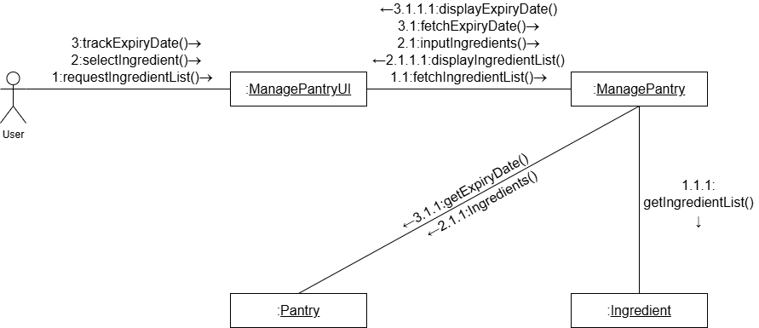

Figure : Collaboration diagram of “Manage Pantry”

**Sequence diagram:**

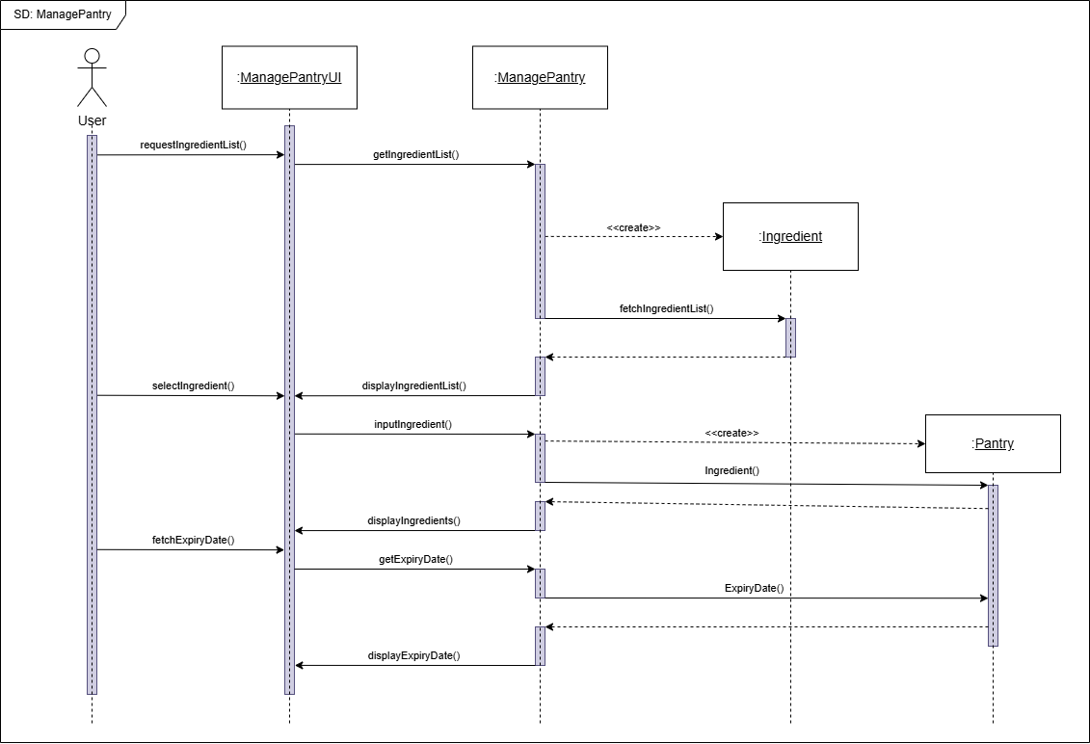

Figure : Sequence diagram of “Manage Pantry”

**Search Recipe**

**Use case:** Search Recipe

**Actor:** User

**Description:** Users search for recipes, and the system generates a list of results. Users apply filters to narrow down the list. The system updates the list based on the selected filters.

**Typical Course of Actions:**

|  |  |
| --- | --- |
| **Actor Action** | **System Response** |
| 1. Users navigate to recipe page. | 2. System displays recipe list from the database. |
| 3. Users filter the recipe list based on their needs. | 4. System displays the filtered recipe list. |

**Domain Class:**

1. Recipe

**Collaboration diagram:**

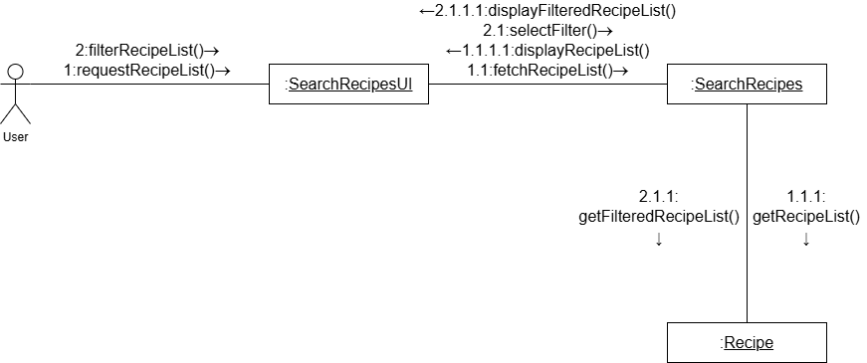

Figure : Collaboration diagram of “Search Recipe”

**Sequence diagram:**

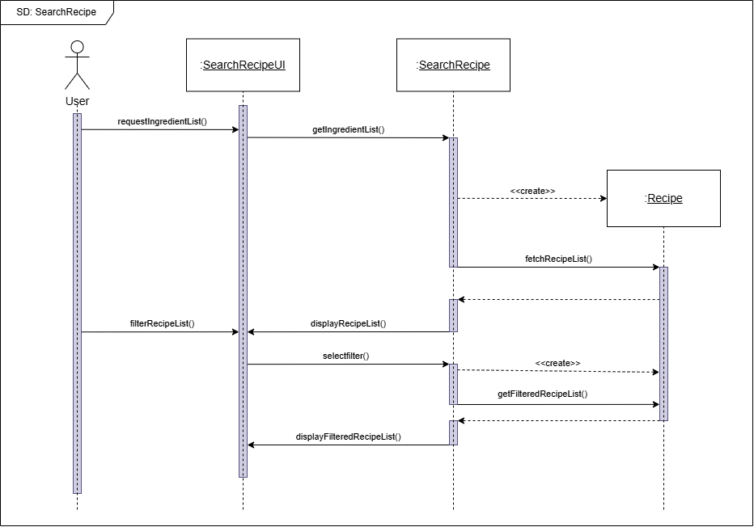

Figure : Sequence diagram for “Search Recipe”

**Make Shopping List**

**Use case:** Make Shopping List

**Actor:** User

**Description:** Users select ingredients that are low in stock or need to be added for a recipe or that was finished. The system provides an ingredient list for users to select from. The shopping list is then generated.

**Typical Course of Actions:**

|  |  |
| --- | --- |
| **Actor Action** | **System Response** |
| 1. Users navigate to shopping list page. | 2. System displays the user’s already existing list. |
| 2. Users add ingredients to the list. | 4. System add the newly selected ingredients to the list. |

**Domain Class:**

1. Ingredients
2. Shopping List

**Collaboration diagram:**

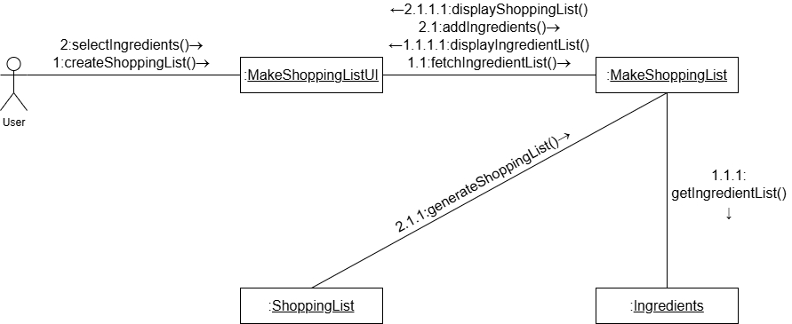

Figure : Collaboration of “Make Shopping List”

**Sequence diagram:**

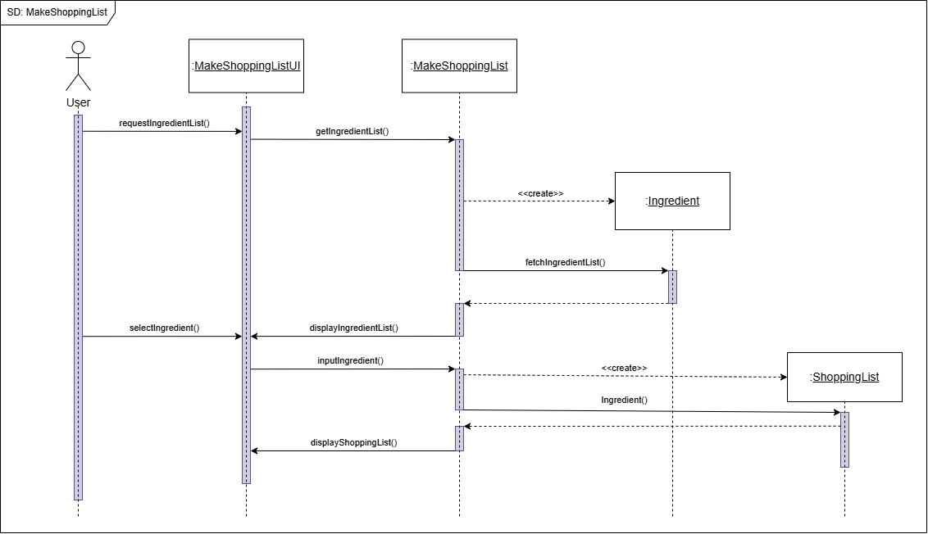

Figure : Sequence diagram for “Make Shopping List”

**Make Post**

**Use case:** Make Post

**Actor:** User

**Description:** Users input the content for a post, and the system validates it. Once validated, users submit the post. The system then publishes it.

**Typical Course of Actions:**

|  |  |
| --- | --- |
| **Actor Action** | **System Response** |
| 1. Users inputs the content of the post. | 2. System validates the content. |
| 3. Users submit the post. | 4. System creates new post and stores it. |
|  | 5. System confirms that the post was created. |

**Domain Class:**

1. Post

**Collaboration diagram:**

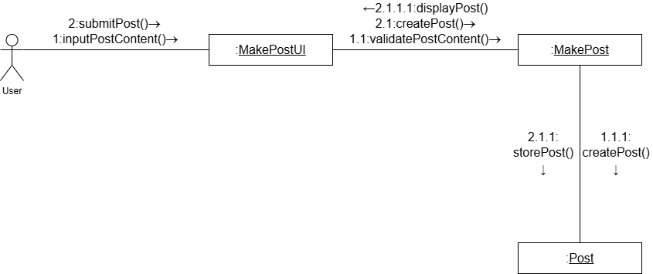

Figure : Collaboration of “Make Post”

**Sequence diagram:**

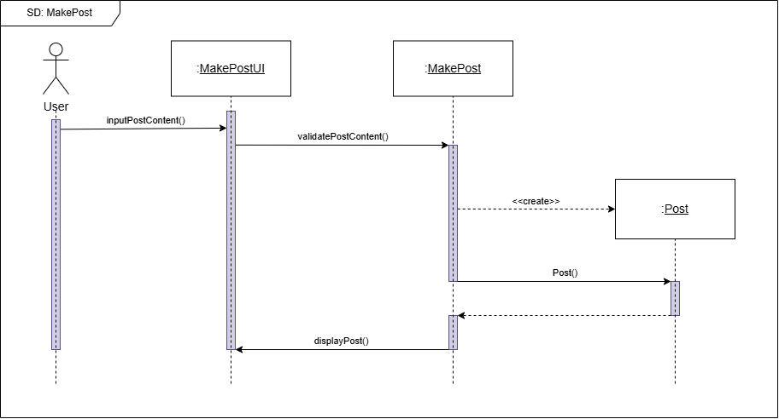

Figure : Sequence diagram for “Make Post”

### Flowchart

A flowchart is a graphical representation of a process or workflow, using standardized symbols to depict steps, decisions, and the flow of tasks. It is widely used to visualize algorithms, workflows, or processes, making complex systems easier to understand. Flowcharts typically include shapes like rectangles (processes), diamonds (decisions), and arrows (flow direction). (Visual Paradigm, 2025)

The flowchart diagram for this project can be found in the appendix area.

## Implementation

### Database

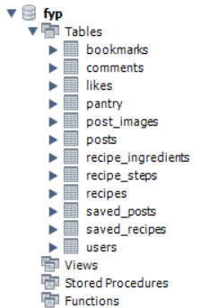

Figure : Database Structure

#### Database Connection:

generator client {

provider = "prisma-client-js"

}

datasource db {

provider = "mysql"

url = env("DATABASE_URL")

}

enum NotificationType {

LIKE

COMMENT

BOOKMARK

MENTION

SHARE

}

model User {

id Int @id @default(autoincrement())

username String @unique

email String @unique

password String

bio String? @db.VarChar(500)

profileImage String?

isPrivate Boolean @default(false)

isVerified Boolean @default(false)

resetToken String?

resetTokenExpiry DateTime?

createdAt DateTime @default(now())

updatedAt DateTime @updatedAt

verificationCode String?

codeExpiry DateTime?

posts Post[]

likes Like[]

comments Comment[]

bookmarks Bookmark[]

searchHistories UserSearchHistory[]

notifications Notification[] @relation("Notification_recipient")

sentNotifications Notification[] @relation("Notification_sender")

// Relation with shopping list items

listItems ListItem[]

}

model Post {

id Int @id @default(autoincrement())

title String @db.VarChar(255)

description String @db.VarChar(255)

imagePaths Json

videoPaths Json?

createdAt DateTime @default(now())

updatedAt DateTime @updatedAt

userId Int

user User @relation(fields: [userId], references: [id])

likes Like[]

comments Comment[]

bookmarks Bookmark[]

notifications Notification[]

}

model Like {

id Int @id @default(autoincrement())

createdAt DateTime @default(now())

updatedAt DateTime @updatedAt

userId Int

postId Int

user User @relation(fields: [userId], references: [id])

post Post @relation(fields: [postId], references: [id], onDelete: Cascade)

@@unique([userId, postId], name: "userId_postId")

}

model Comment {

id Int @id @default(autoincrement())

text String

userId Int

postId Int

parentId Int?

user User @relation(fields: [userId], references: [id])

post Post @relation(fields: [postId], references: [id], onDelete: Cascade)

createdAt DateTime @default(now())

updatedAt DateTime @updatedAt

// Relation fields

replies Comment[] @relation("CommentReplies") // Child comments

parent Comment? @relation("CommentReplies", fields: [parentId], references: [id])

}

model Bookmark {

id Int @id @default(autoincrement())

userId Int

postId Int

createdAt DateTime @default(now())

updatedAt DateTime @updatedAt

user User @relation(fields: [userId], references: [id])

post Post @relation(fields: [postId], references: [id], onDelete: Cascade)

@@unique([userId, postId], name: "unique_bookmark")

}

model Notification {

id Int @id @default(autoincrement())

type NotificationType

read Boolean @default(false)

createdAt DateTime @default(now())

updatedAt DateTime @updatedAt

// Relationships

recipient User @relation("Notification_recipient", fields: [recipientId], references: [id])

recipientId Int

sender User @relation("Notification_sender", fields: [senderId], references: [id])

senderId Int

post Post? @relation(fields: [postId], references: [id])

postId Int?

}

model Recipe {

id String @id @default(cuid())

name String

imageUrl String

description String

ingredients RecipeIngredient[]

tags RecipeTag[]

steps Step[]

}

model Tag {

id Int @id @default(autoincrement())

name String @unique

recipes RecipeTag[]

searchHistories UserSearchHistory[]

}

model Ingredient {

id Int @id @default(autoincrement())

name String @unique

recipes RecipeIngredient[]

}

model RecipeTag {

id Int @id @default(autoincrement())

recipe Recipe @relation(fields: [recipeId], references: [id])

recipeId String

tag Tag @relation(fields: [tagId], references: [id])

tagId Int

}

model RecipeIngredient {

id Int @id @default(autoincrement())

recipe Recipe @relation(fields: [recipeId], references: [id])

recipeId String

ingredient Ingredient @relation(fields: [ingredientId], references: [id])

ingredientId Int

}

model Step {

id Int @id @default(autoincrement())

order Int

content String

recipeId String

recipe Recipe @relation(fields: [recipeId], references: [id])

}

model ListItem {

id Int @id @default(autoincrement())

name String

quantity Float

unit String

isChecked Boolean @default(false)

createdAt DateTime @default(now())

// Relation to User (Each user has their own list)

userId Int

user User @relation(fields: [userId], references: [id])

}

model UserSearchHistory {

id String @id @default(cuid())

userId Int

tagId Int

createdAt DateTime @default(now())

user User @relation(fields: [userId], references: [id])

tag Tag @relation(fields: [tagId], references: [id])

}

### Code Implementation

#### User Login

#### User Registration

#### Get All Recipe

#### Scanner

#### Add item to Pantry

#### Create and store posts

#### User Profile

# Testing and Analysis

## Test Plan

## System Testing

### Authentication Testing

Table : Registration test case

|  |  |
| --- | --- |
| Objective | Verify that a new user can successfully register and is redirected to the login page upon completion. |
| Action | Fill in the required fields (username, email, and password), then click the Register button. |
| Expected result | Upon successful registration, the user should get a success message. |
| Actual result | After registration, the user successfully received a successful message. |
| Conclusion | The test is successful. |

**Proof:**

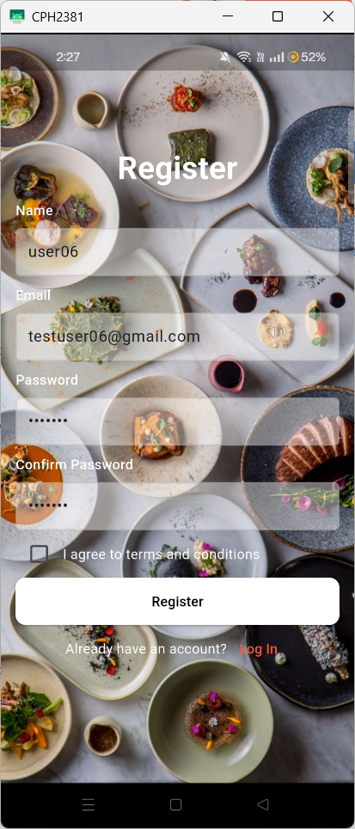

Figure : Registering new user

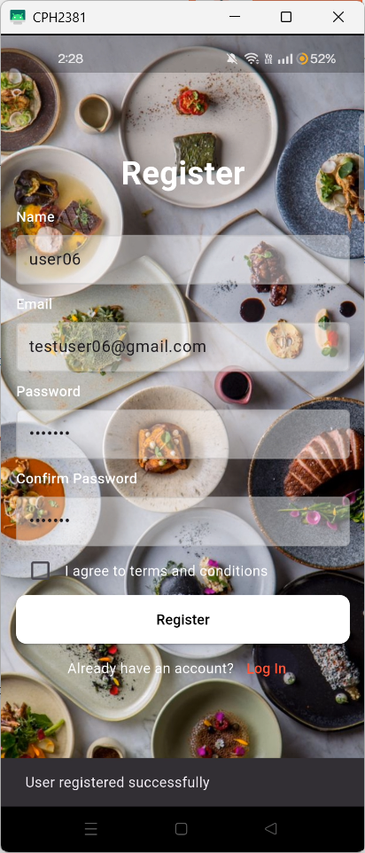

Figure : Login page

Table : Login test case

|  |  |
| --- | --- |
| Objective | Confirm that a registered user can log in and gain access to the application. |
| Action | Enter valid login credentials (email and password), then click the Login button. |
| Expected result | Upon successful authentication, the user should be redirected to the home page. |
| Actual result | The user was successfully authenticated and redirected to the home page. |
| Conclusion | The test is successful. |

**Proof:**

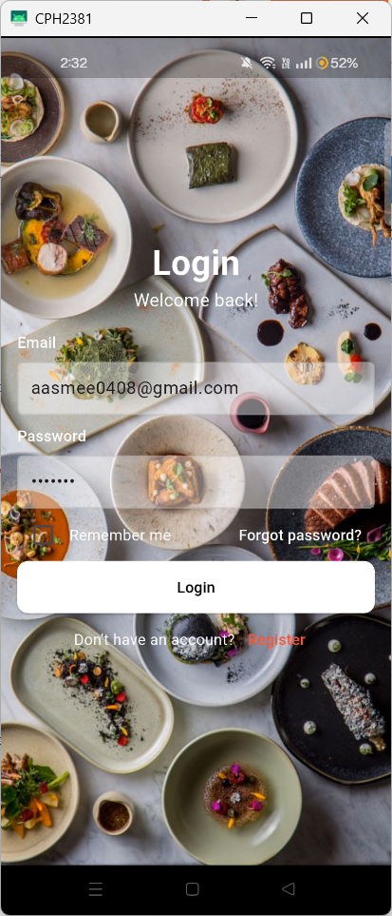

Figure : Entering login credentials



Figure : Home page

Table : Adding pantry item test case

|  |  |
| --- | --- |
| Objective | To verify the functionality of adding a new ingredient to the pantry. |
| Action | Navigate to the Pantry page, click the **"Add Ingredients"** button, enter the required ingredient details, and confirm the addition. |
| Expected result | The newly added ingredient should appear on the Pantry page, correctly categorized under its respective section |
| Actual result | The ingredient appeared on the Pantry page as expected, under the correct category. |
| Conclusion | The test is successful. |

**Proof:**

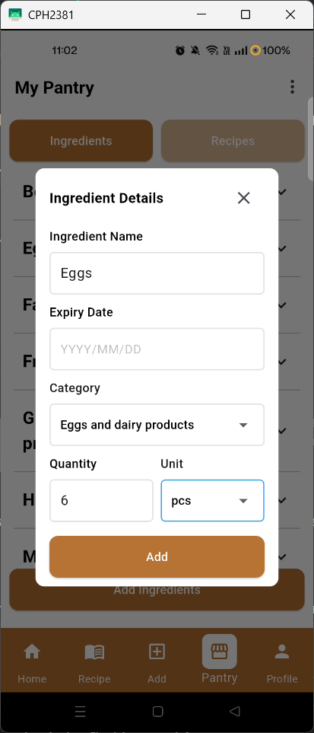

Figure : Adding item to pantry

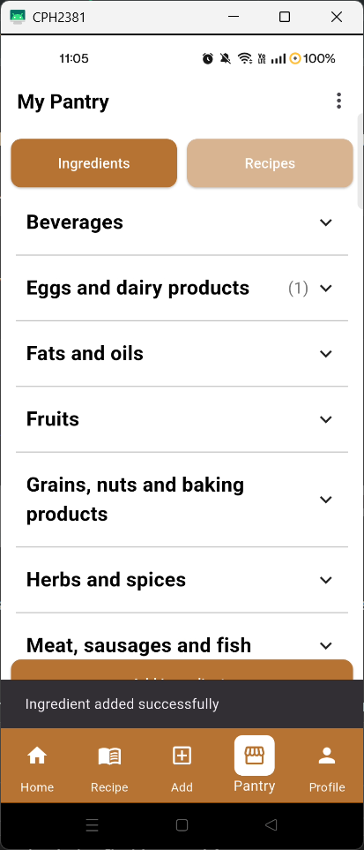

Figure : Succession message

Table : Creating post test case

|  |  |
| --- | --- |
| Objective | To verify that a new post can be successfully created, stored in the database, and retrieved for display on the homepage. |
| Action | Select preferred images, write a caption, click the “POST” button, and then navigate to the homepage. |
| Expected result | The new post should be saved in the database and correctly displayed on the homepage. |
| Actual result | The post was successfully created, stored in the database, and displayed on the homepage. |
| Conclusion | The test is successful. |

**Proof:**

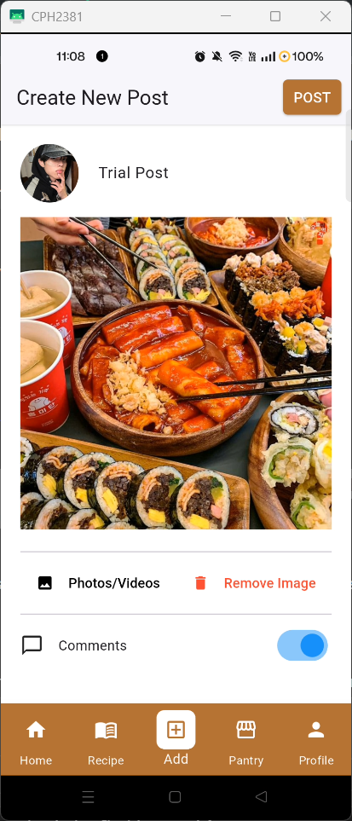

Figure : Creating a new post

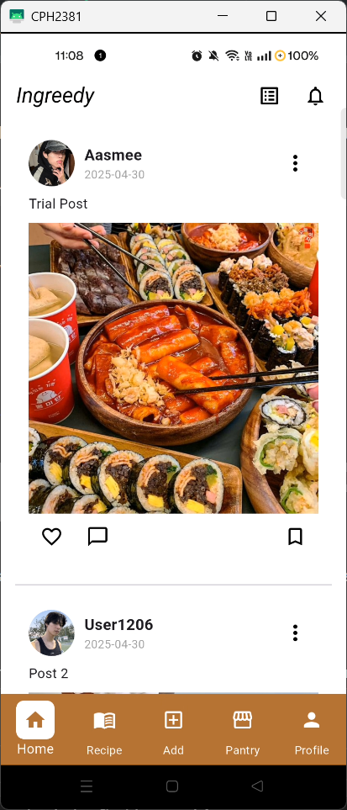

Figure : New post in home page

Table : Making comment test case

|  |  |
| --- | --- |
| Objective | To verify that users can successfully post a comment and have it displayed correctly. |
| Action | Tap the chat button, enter a comment, and submit it by clicking “Post”. |
| Expected result | The newly submitted comment should appear at the top of the comment section. |
| Actual result | The new comment appeared at the top of the comment section as expected. |
| Conclusion | The test is successful. |



Figure : Comments box

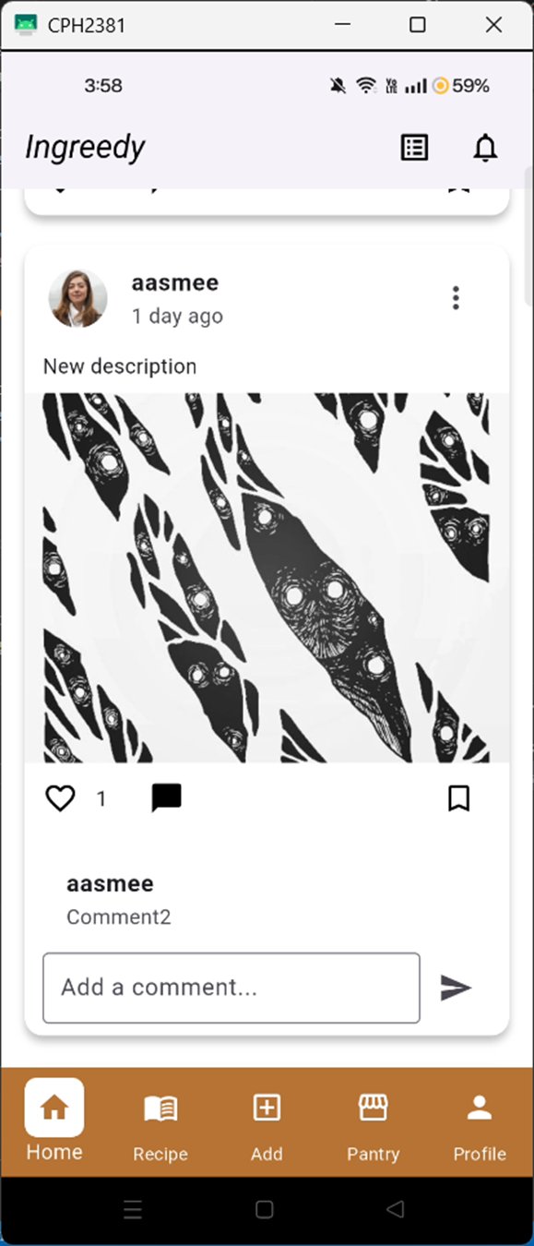

Figure : New comment added





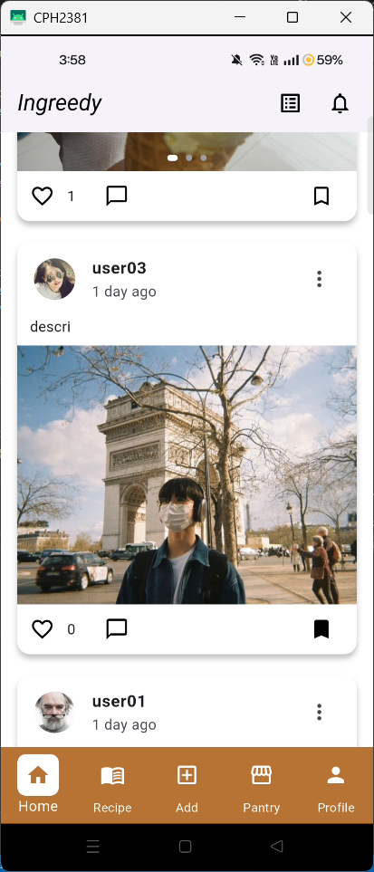



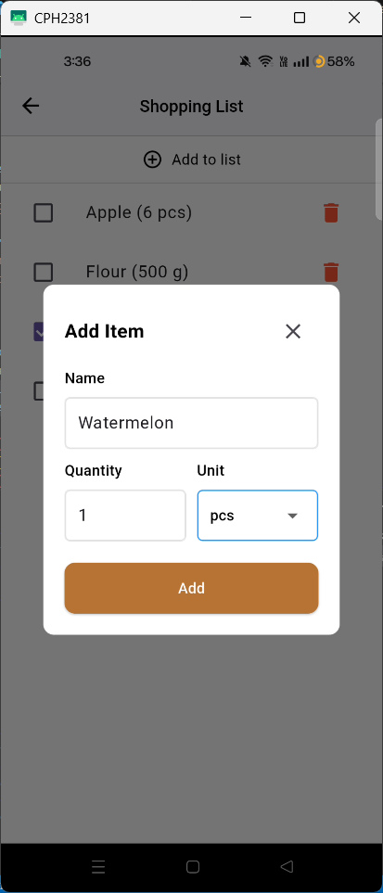

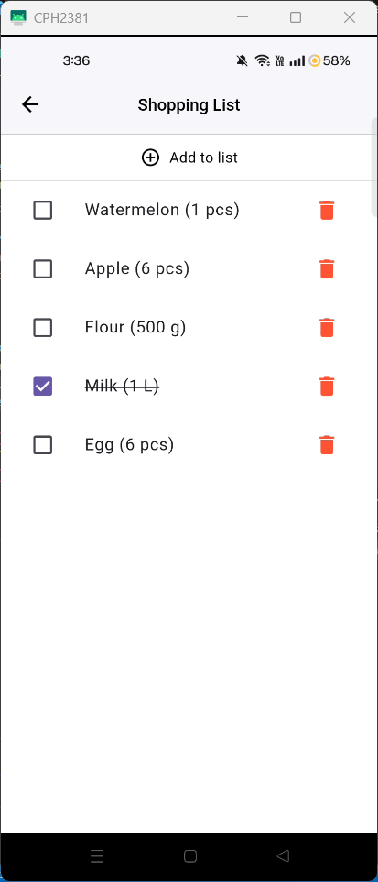

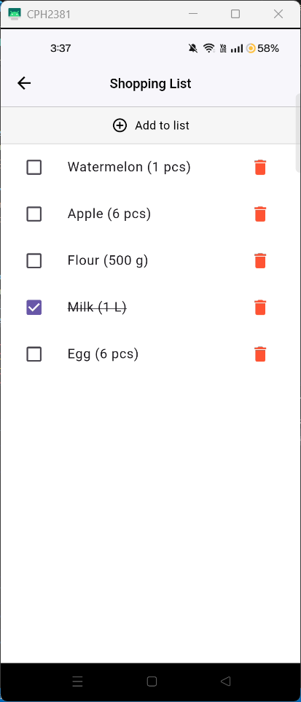

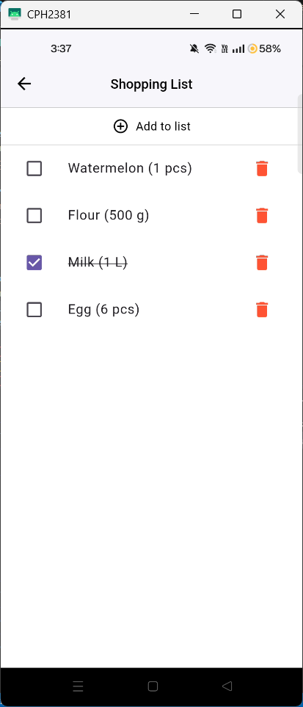

## API testing

### Register

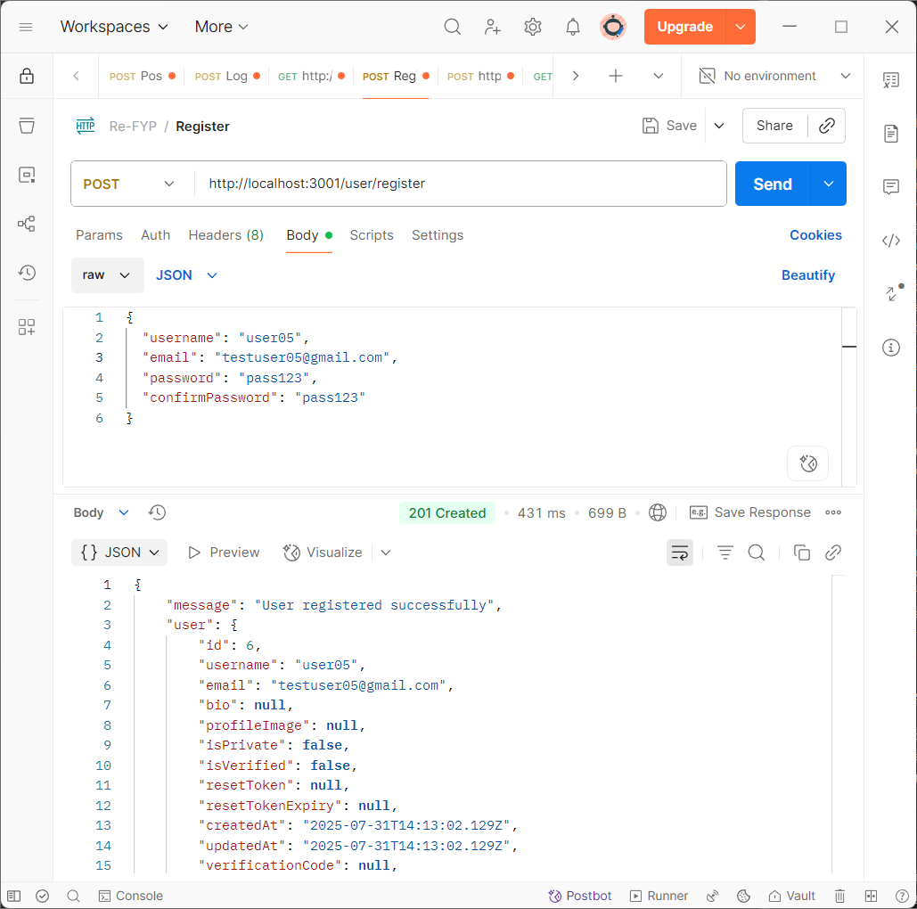

Figure : Register API testing

### Login

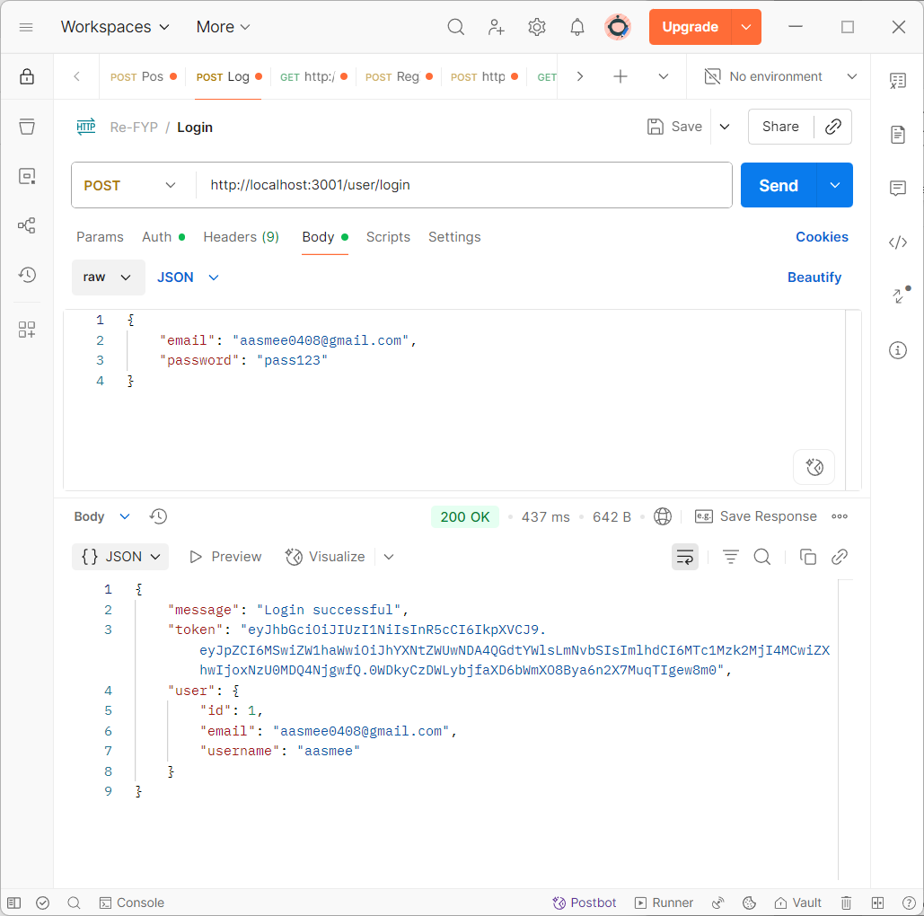

Figure : Login API testing

### Make post

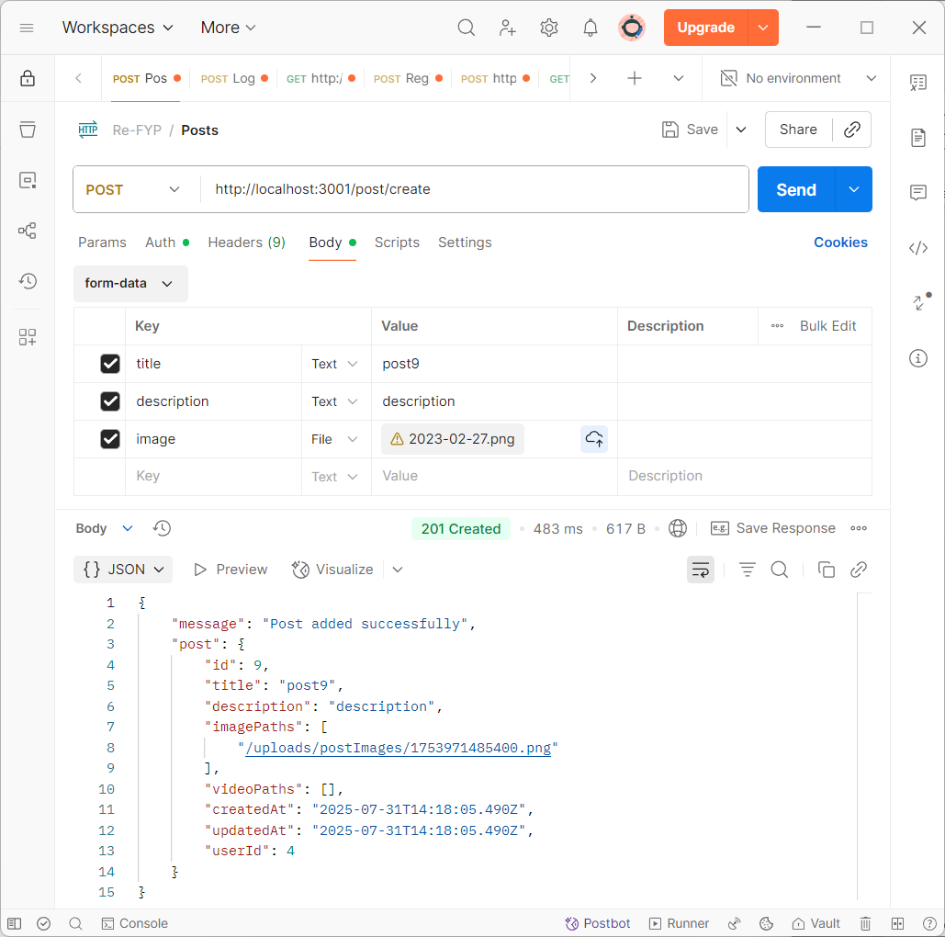

Figure : Post creation API testing

### Get post

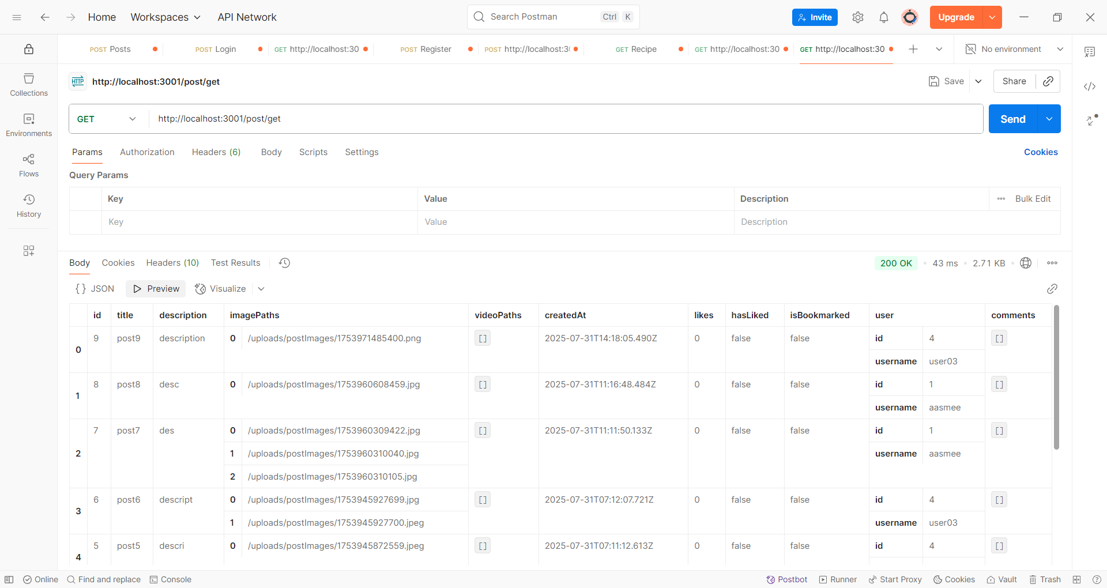

Figure : Get post API testing

### Delete post

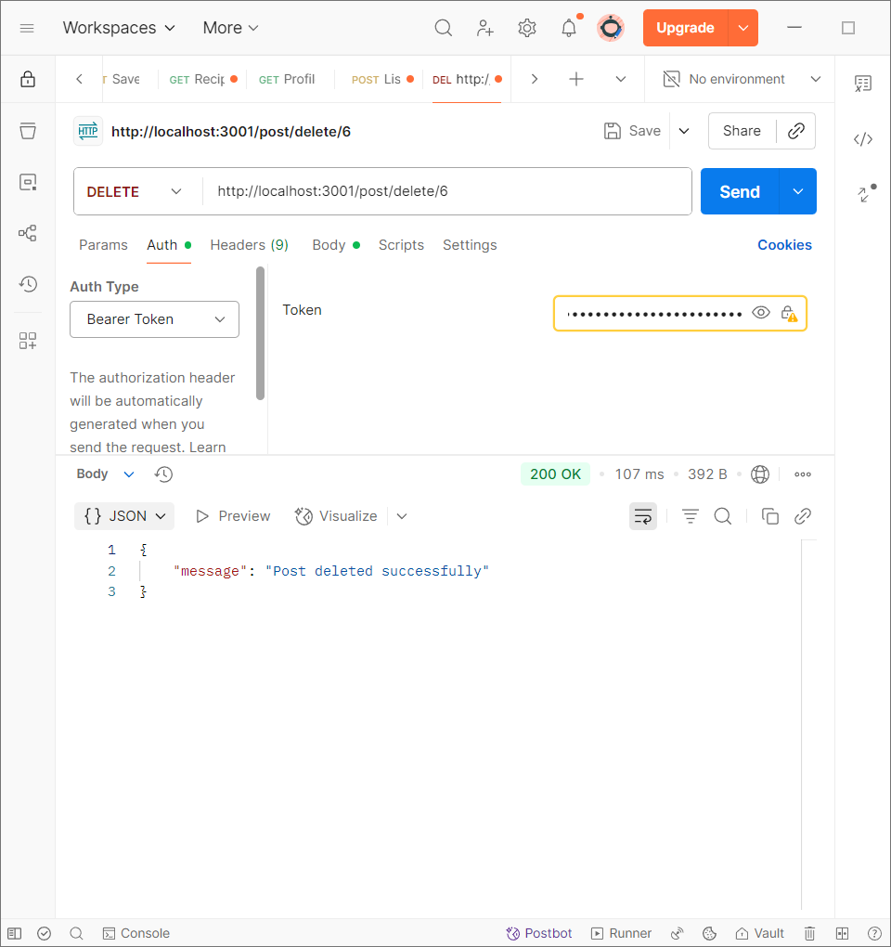

Figure : Deleting post API testing

### Update posts

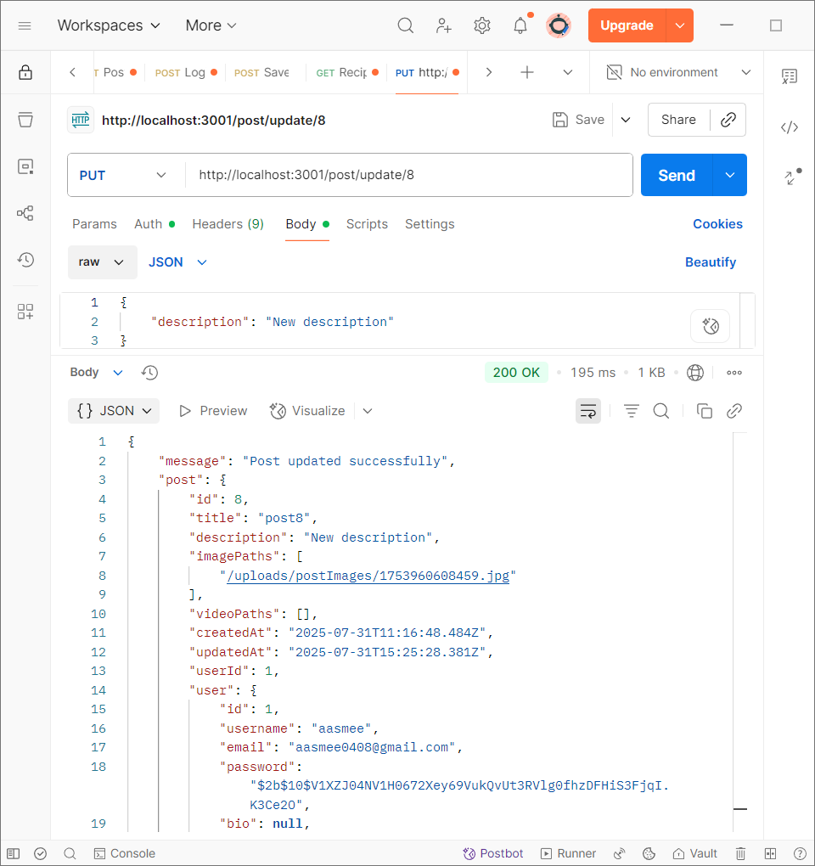

Figure : Updating posts API testing

### Like post

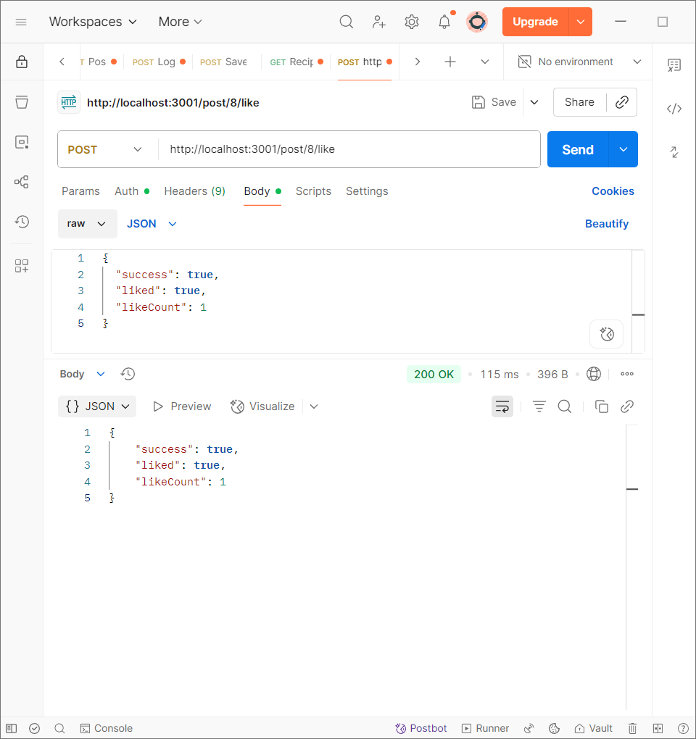

Figure : Liking post API testing

### Bookmark posts

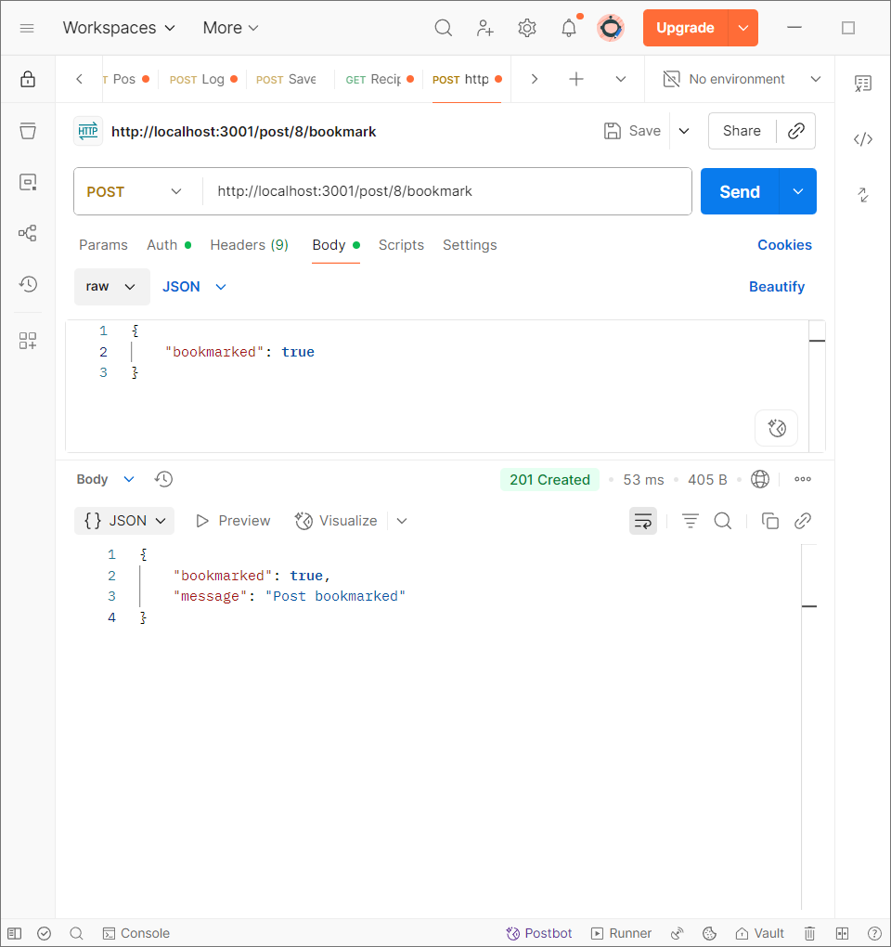

Figure : Bookmarking posts API testing

### View bookmarked posts

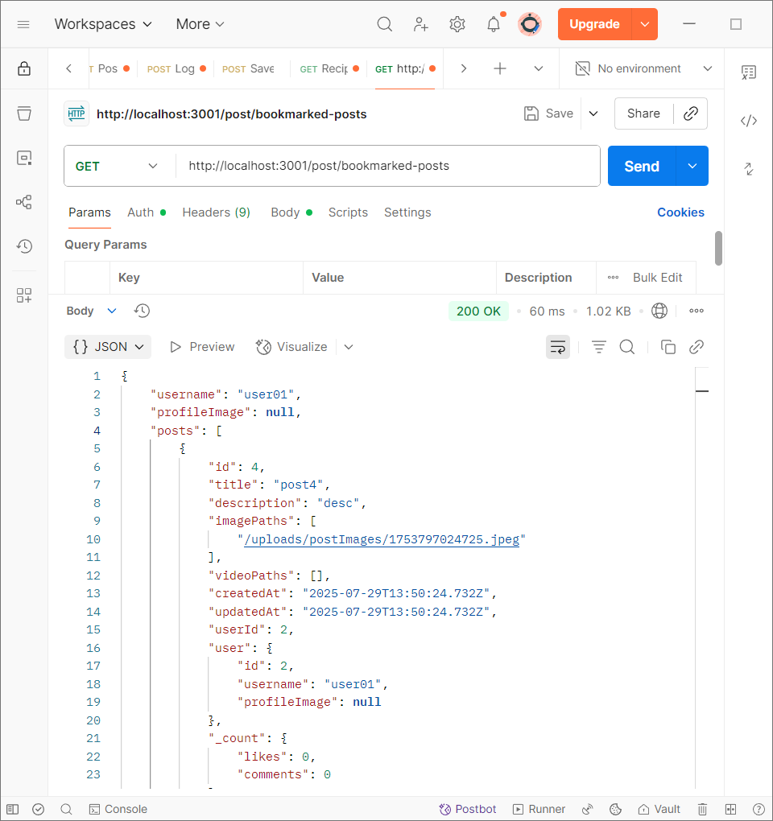

Figure : View bookmarked posts API testing

### Get single post

### Add comment

### Get comment

### Delete comment

### Edit comment

### Get notification

### Read notifications

### Add items to Shopping List

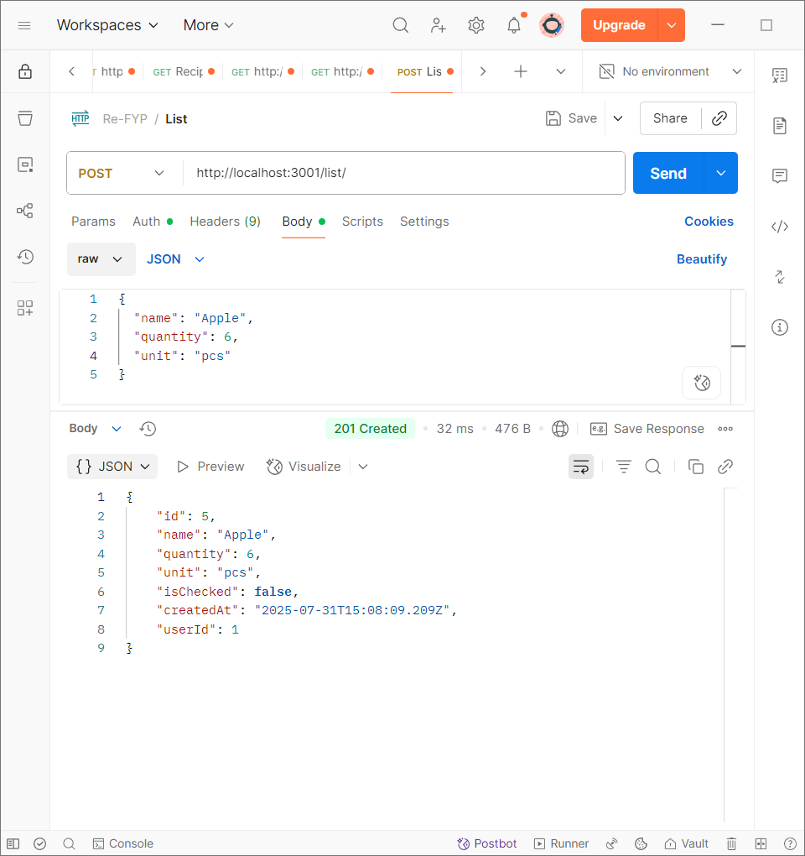

Figure : Adding items to list API testing

### Get shopping list

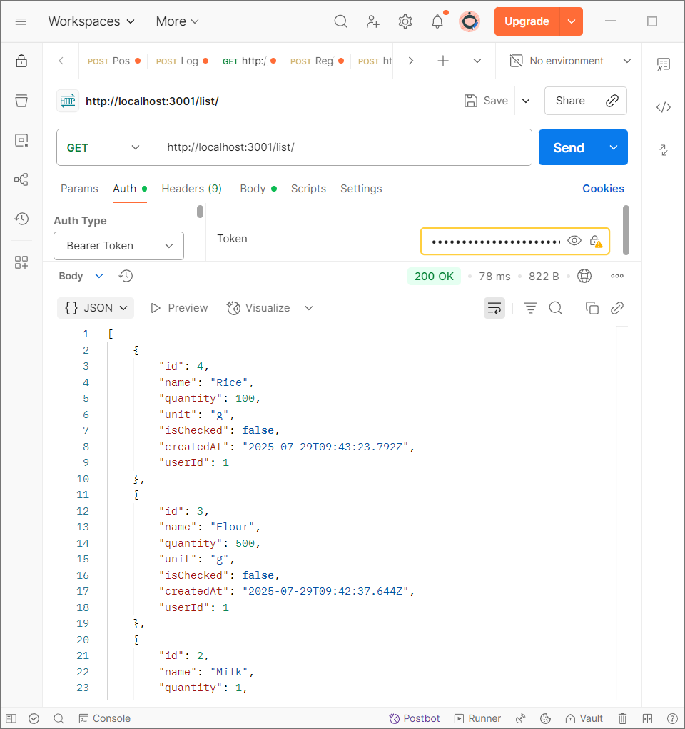

Figure : Get shopping list of the active user API testing

### Update list

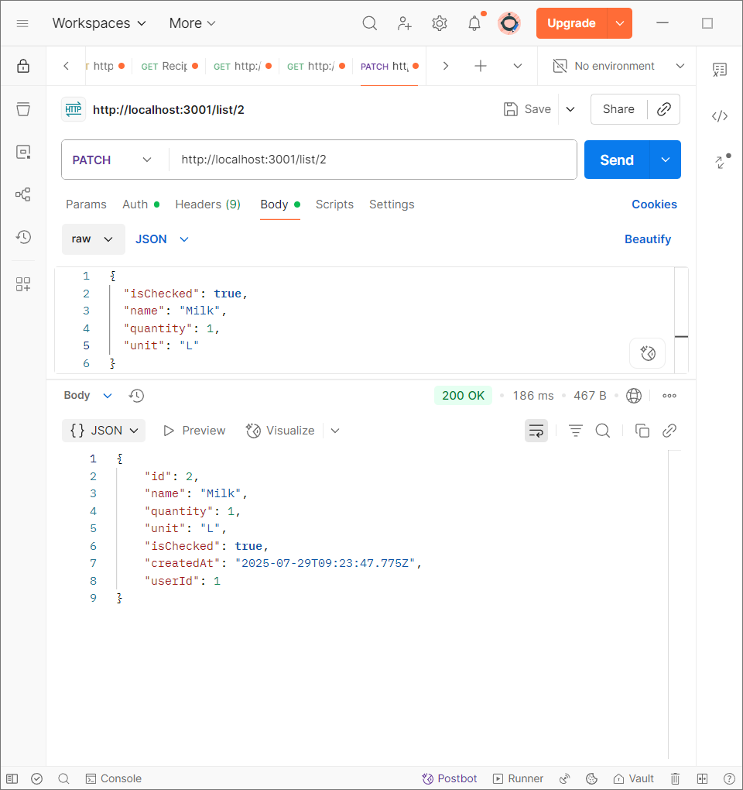

Figure : Update shopping list item API testing

### Delete list item

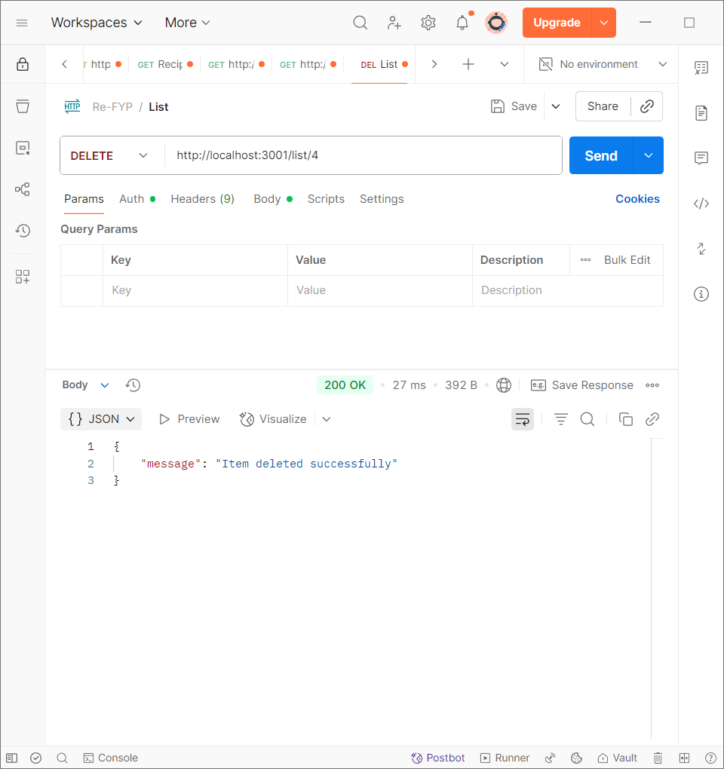

Figure : Deleting list item API testing

### Get all recipes

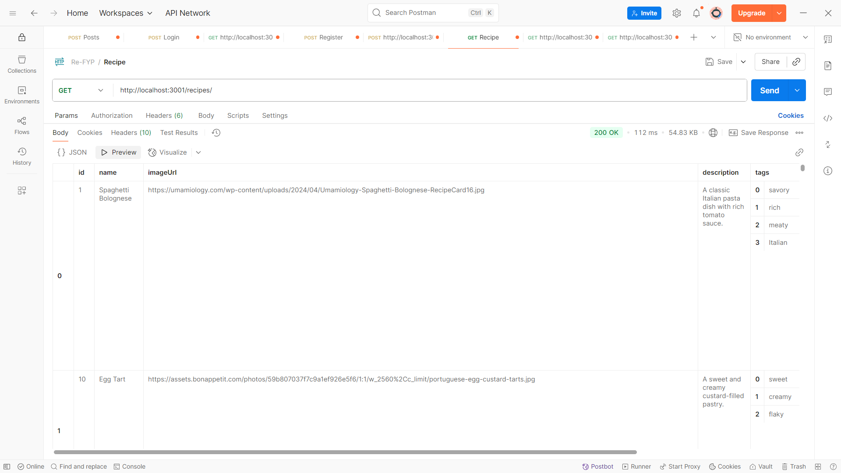

Figure : Get all recipes API testing

### Get a single recipe

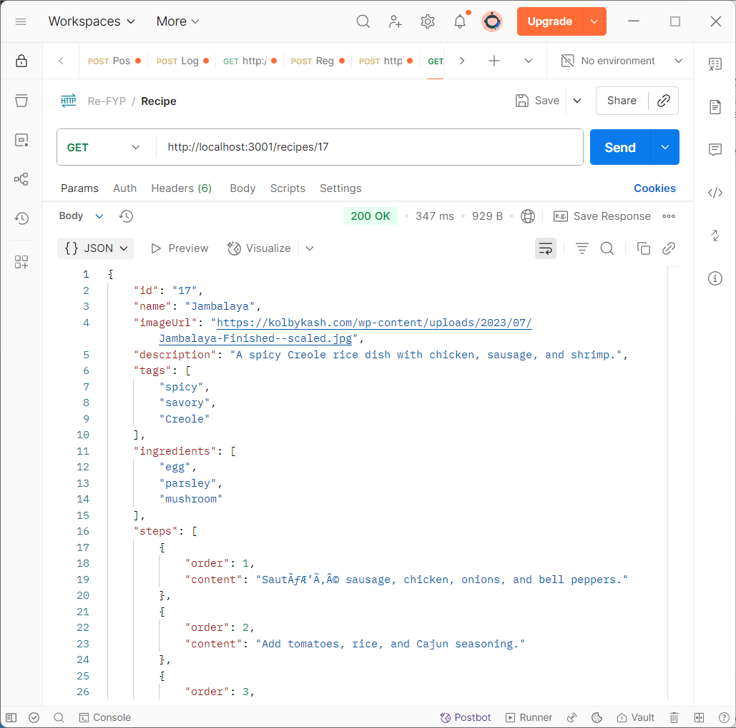

Figure : Get a single recipe by id API testing

### Save search tags

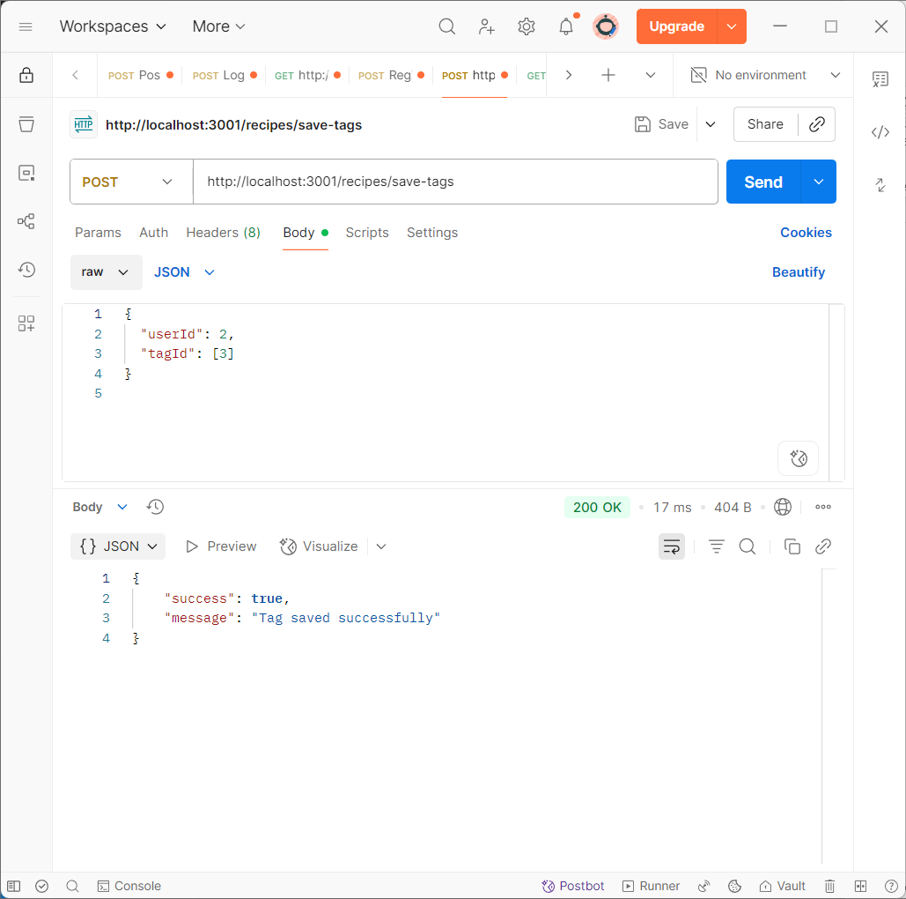Figure : Save tags from the user’s search API testing

### Get profile

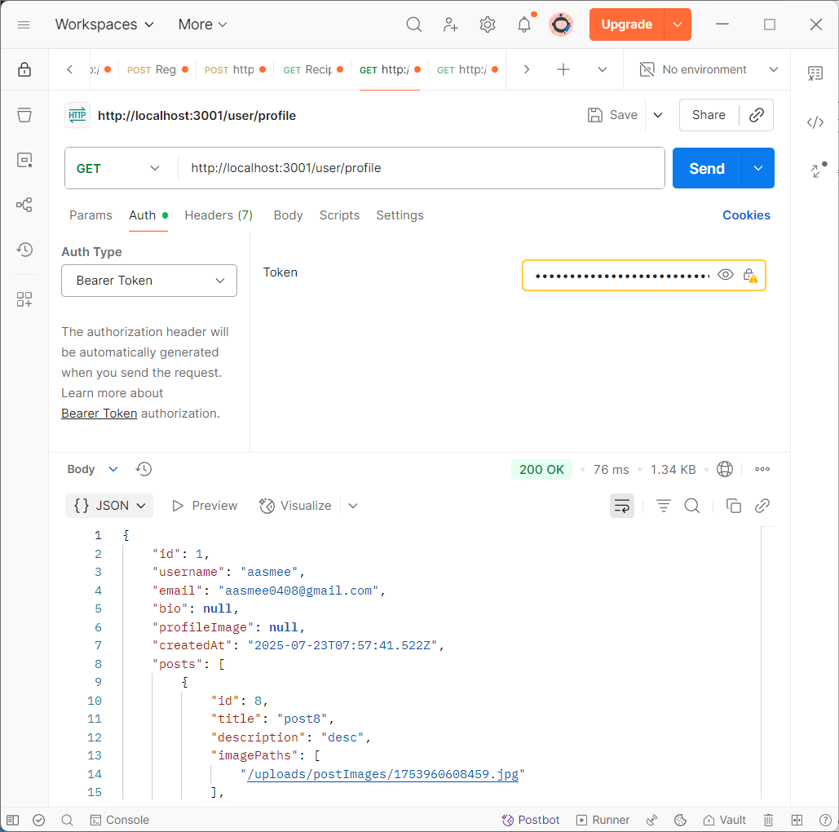

Figure : Get user profile API testing

# Conclusion

## Advantages

## Limitations

# Future Work

# References

1. Aptoide, 2025. *Cookpad recipes, homemade food -.* [Online]   
   Available at: https://cookpad.en.aptoide.com/app  
   [Accessed 06 January 2025].
2. Aptoide, 2025. *Yummly Recipes & Cooking Tools.* [Online]   
   Available at: https://yummly.en.aptoide.com/app  
   [Accessed 06 January 2025].
3. creately, 2022. *Use Case Digram Tutorial (Guide with Examples).* [Online]   
   Available at: https://creately.com/guides/use-case-diagram-tutorial/  
   [Accessed 25 4 2025].
4. Fakhroutdinov, K., 2025. *UML use case diagrams graphical notation reference.* [Online]   
   Available at: https://www.uml-diagrams.org/use-case-reference.html  
   [Accessed 27 4 2025].
5. Huff, B., 2022. *'What shall we have for dinner?' Choice overload is a real problem, but these tips will make your life easier.* [Online]   
   Available at: https://theconversation.com/what-shall-we-have-for-dinner-choice-overload-is-a-real-problem-but-these-tips-will-make-your-life-easier-193317  
   [Accessed 1 December 2023].
6. Porter, S. D. & Reay, D. S., 2015. *Addressing food supply chain and consumption inefficiencies: potential for climate change mitigation.* [Online]   
   Available at: https://link.springer.com/article/10.1007/s10113-015-0783-4  
   [Accessed 1 December 2023].
7. Sensor Tower, 2025. *Tasty: Recipes, Cooking Videos - Overview.* [Online]   
   Available at: https://app.sensortower.com/overview/1217456898?country=US  
   [Accessed 06 January 2025].
8. THE OWL, 2024. *What is Inventory Expiration and How Can Food Manufacturers Prevent It?.* [Online]   
   Available at: https://theowlsolutions.com/inventory-expiration-and-how-to-prevent-it/  
   [Accessed 1 December 2024].
9. Valcheva, S., 2025. *Data Flow Diagram.* [Online]   
   Available at: https://www.intellspot.com/data-flow-diagram-examples/  
   [Accessed 28 4 2025].
10. Visual Paradigm, 2025. *Flowchart Tutorial (with Symbols, Guid and Examples).* [Online]   
    Available at: https://www.visual-paradigm.com/tutorials/flowchart-tutorial/  
    [Accessed 28 04 2025].

# Appendix

## Appendix A: Pre-Survey

### Pre-Survey Form

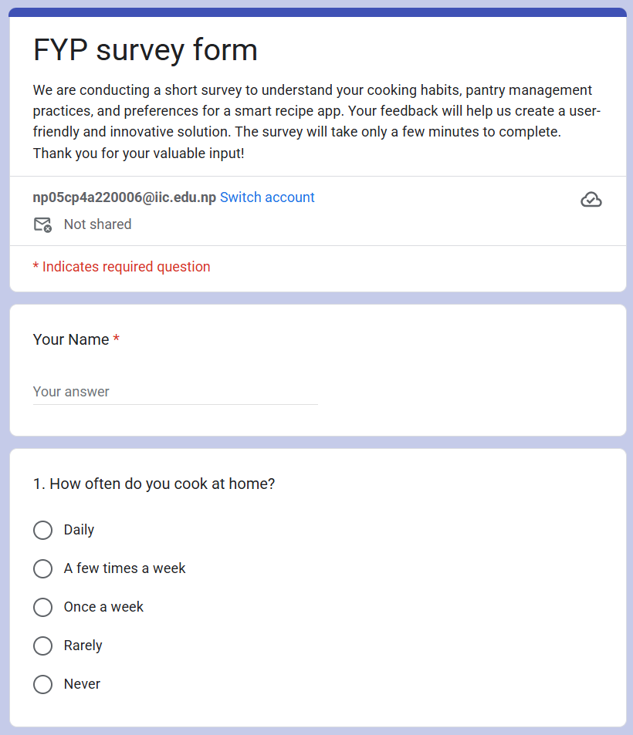

Figure : Pre-Survey Form pt.1

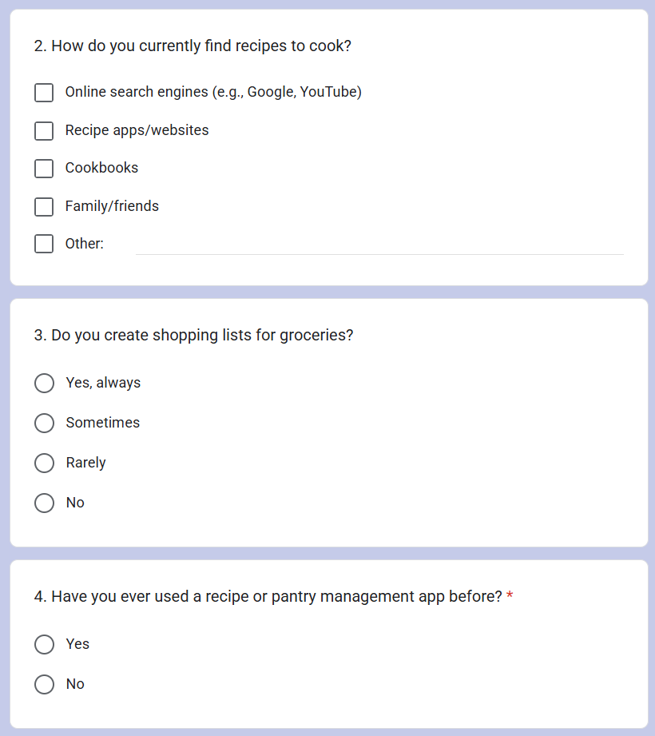

Figure : Pre-Survey Form pt.2

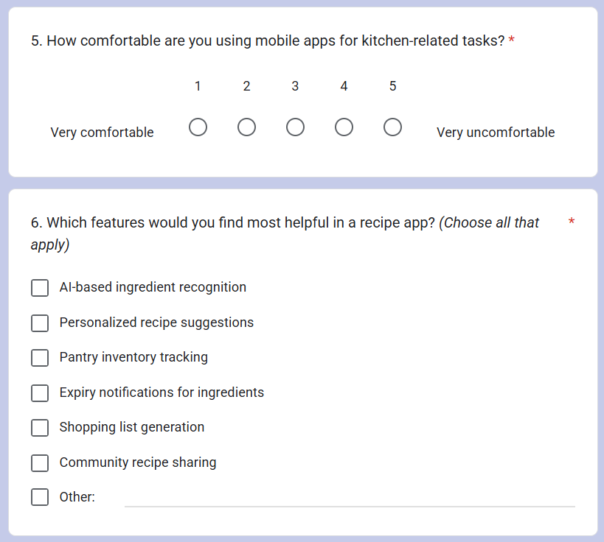

Figure : Pre-Survey Form pt.3

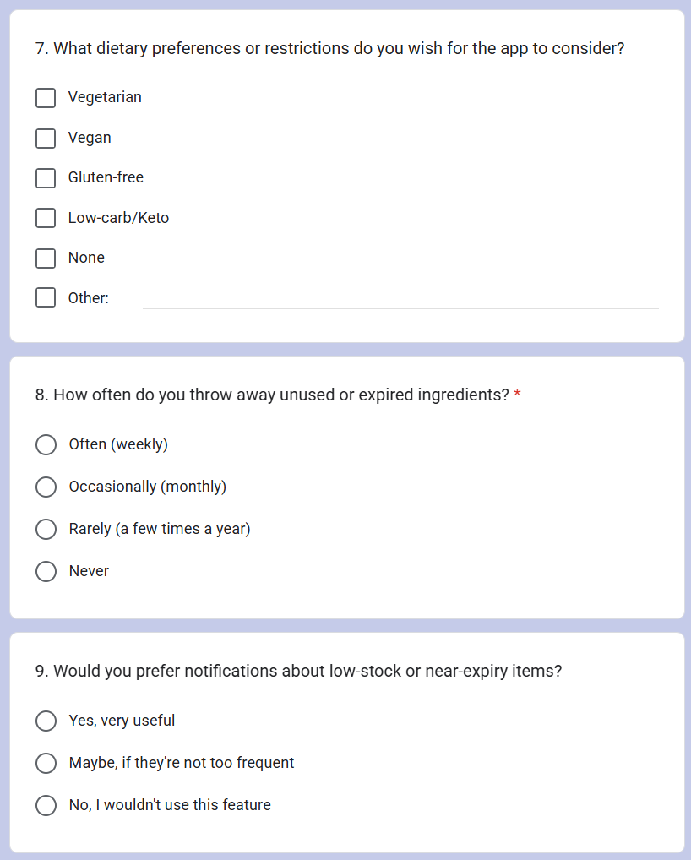

Figure : Pre-Survey Form pt.4

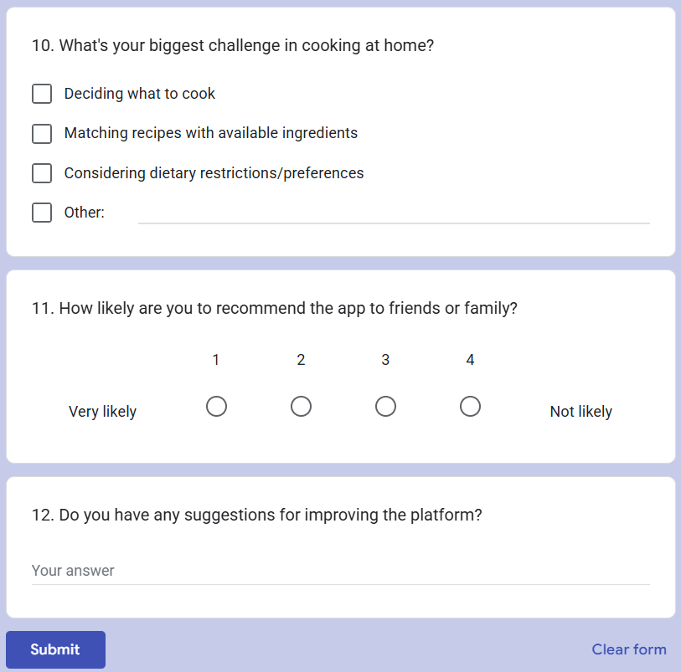

Figure : Pre-Survey Form pt.5

### Sample of Filled Pre-Survey Forms

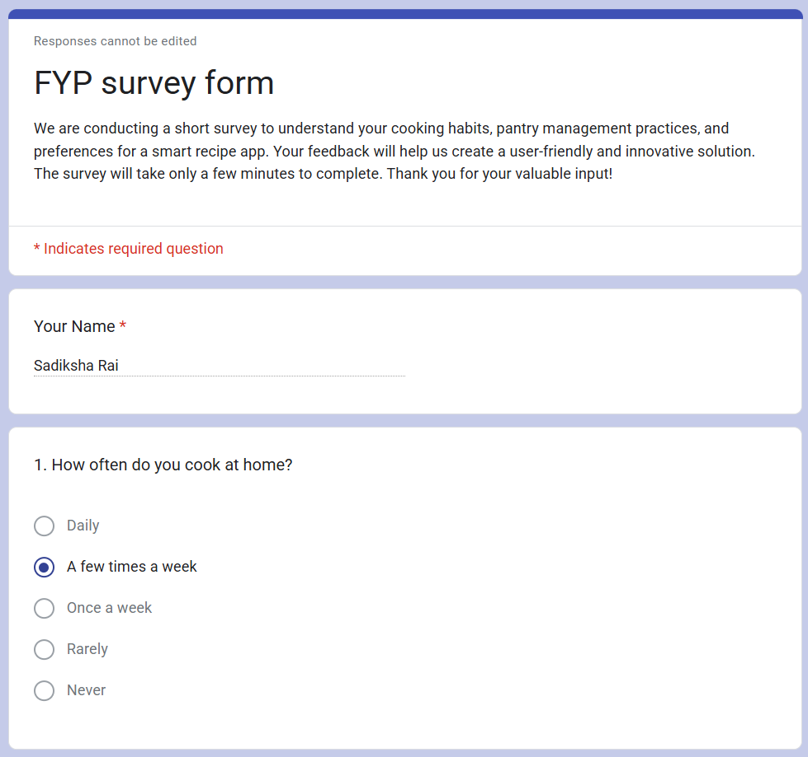

Figure : Filled Pre-Survey Form Sample pt.1

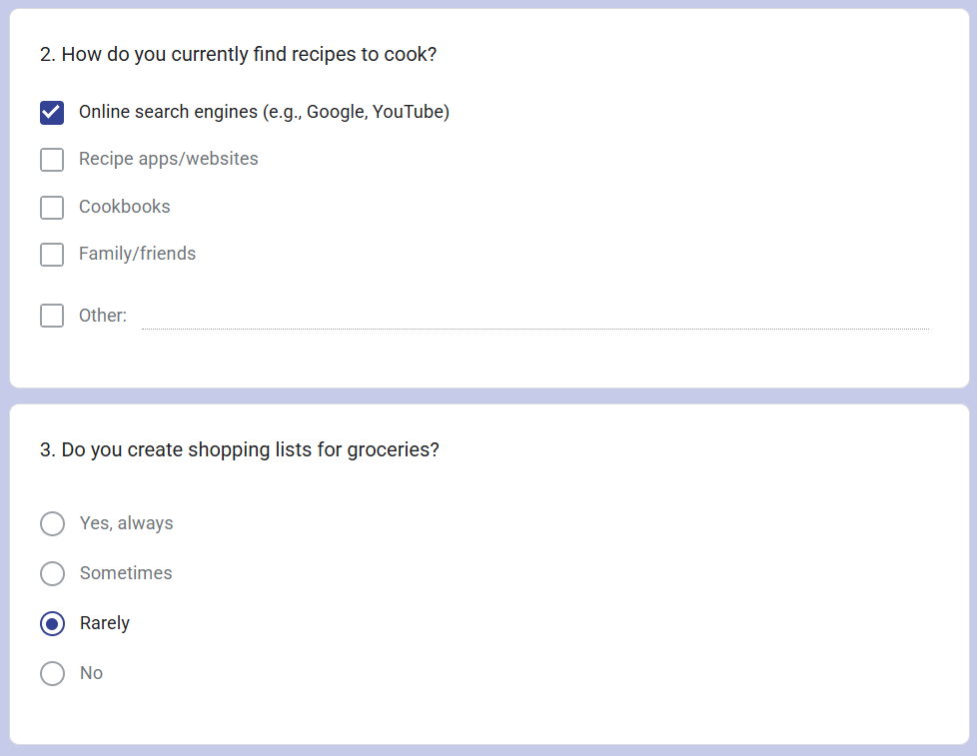

Figure : Filled Pre-Survey Form Sample pt.2

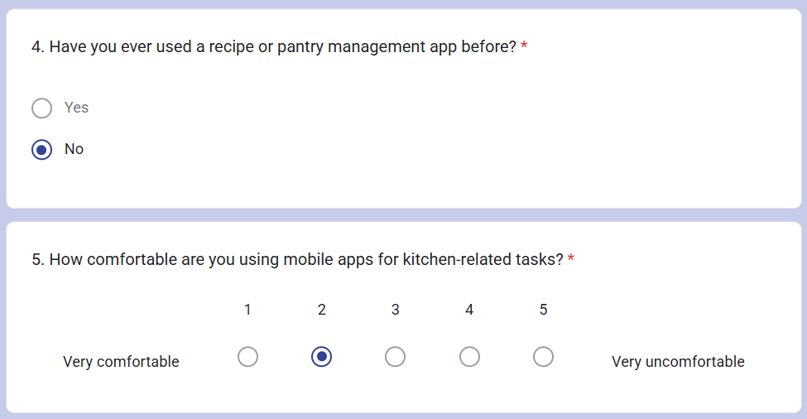

Figure : Filled Pre-Survey Form Sample pt.3

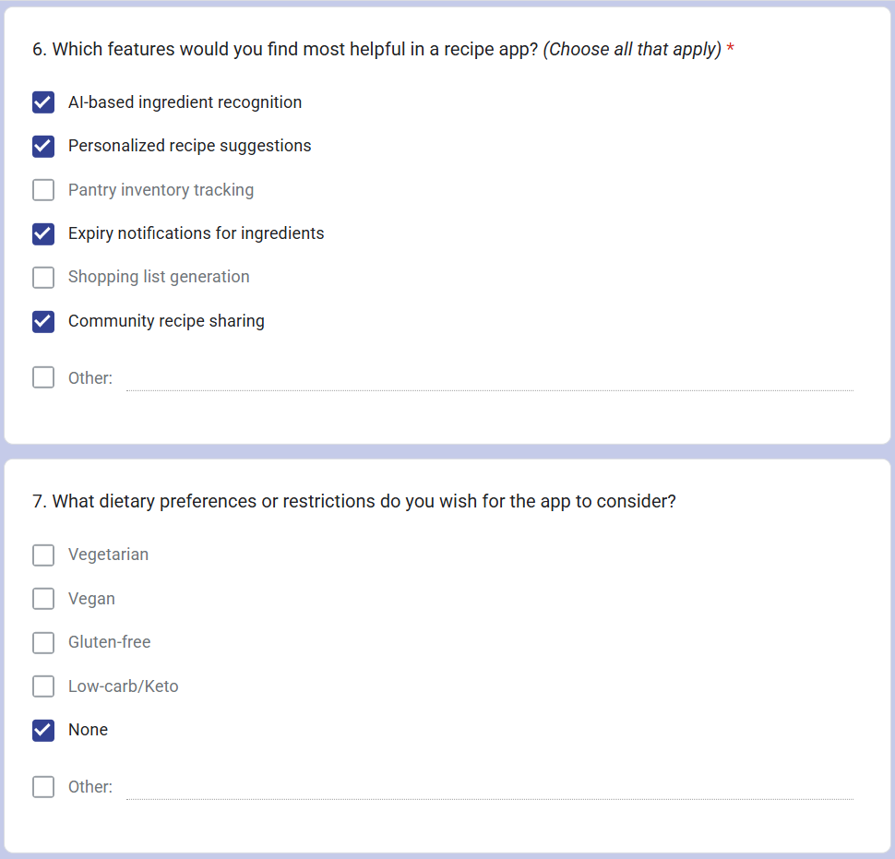

Figure : Filled Pre-Survey Form Sample pt.4

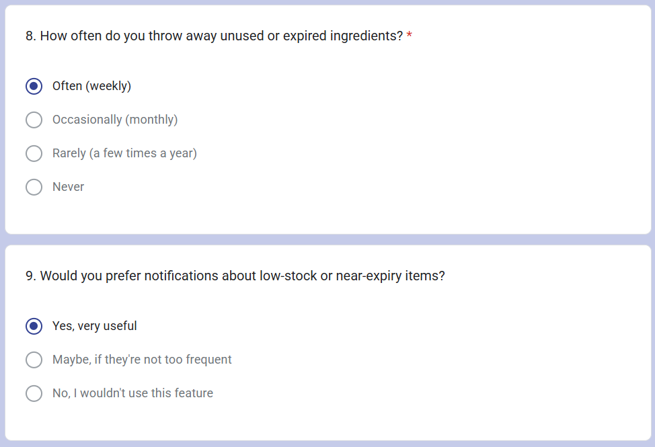

Figure : Filled Pre-Survey Form Sample pt.5

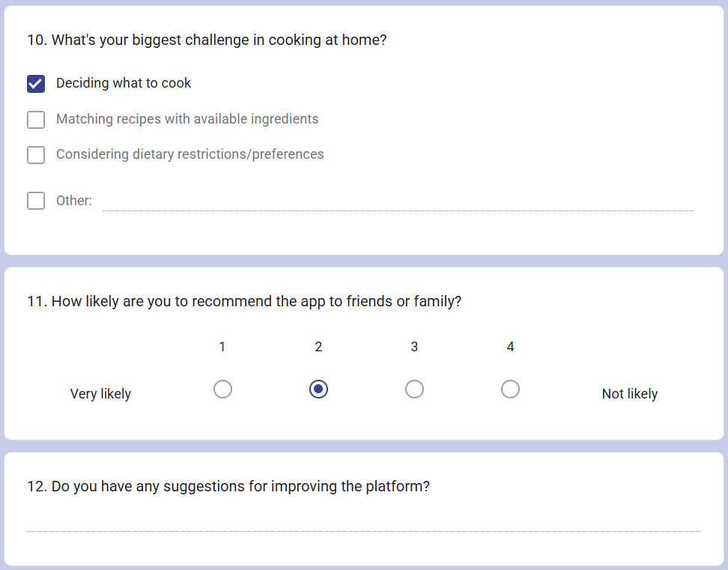

Figure : Filled Pre-Survey Form Sample pt.6

### Pre-Survey Result

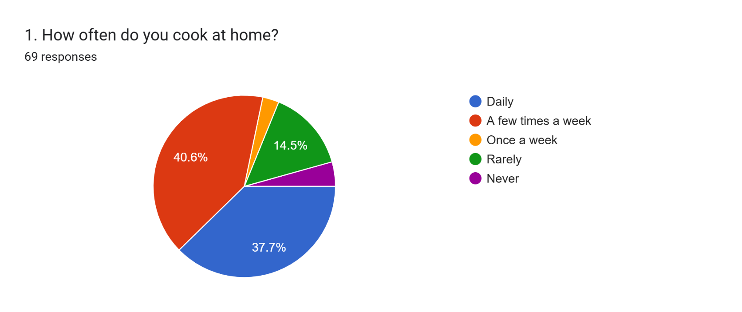

Figure : Pre-Survey Q1

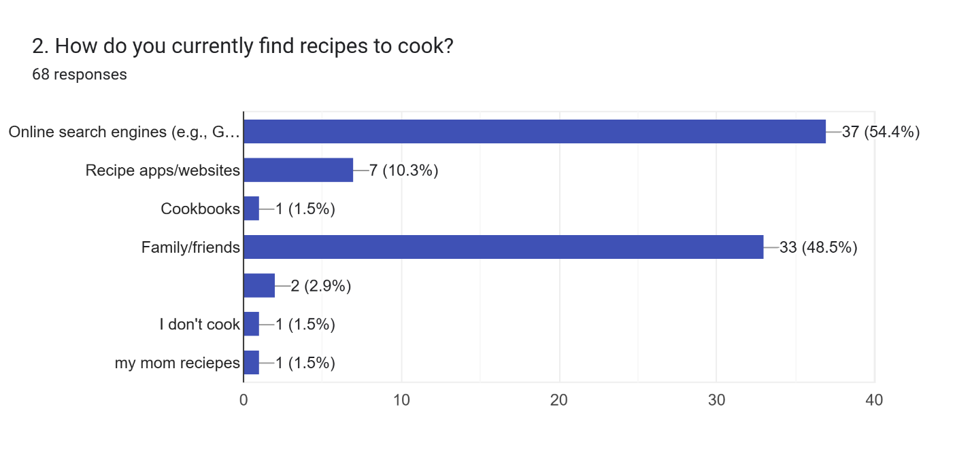

Figure : Pre-Surgery Q2

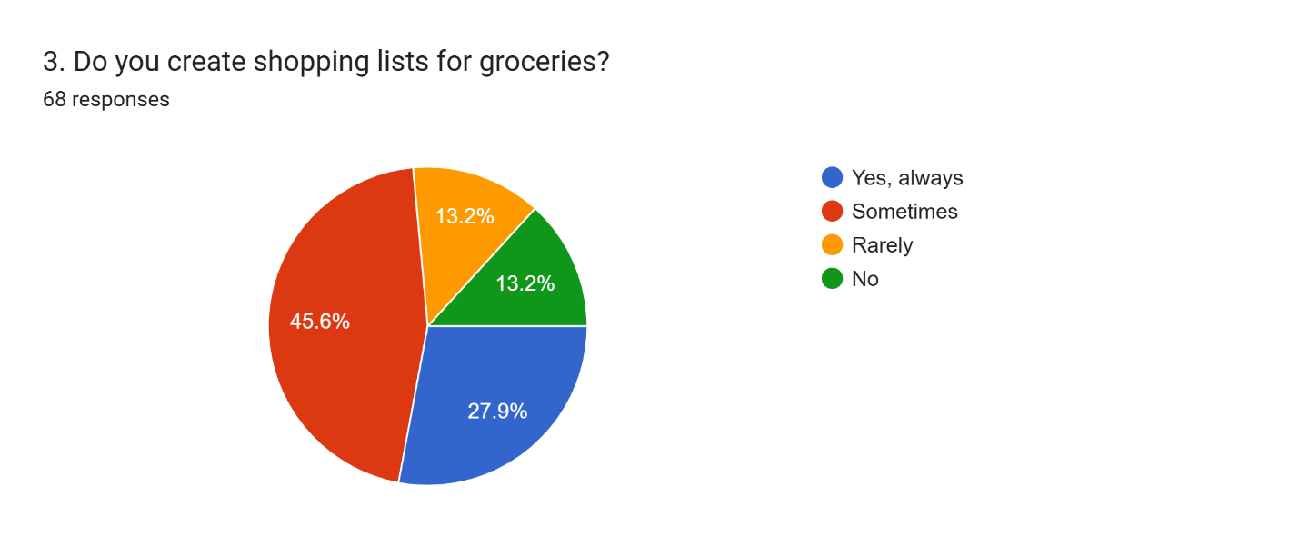

Figure : Pre-Survey Q3

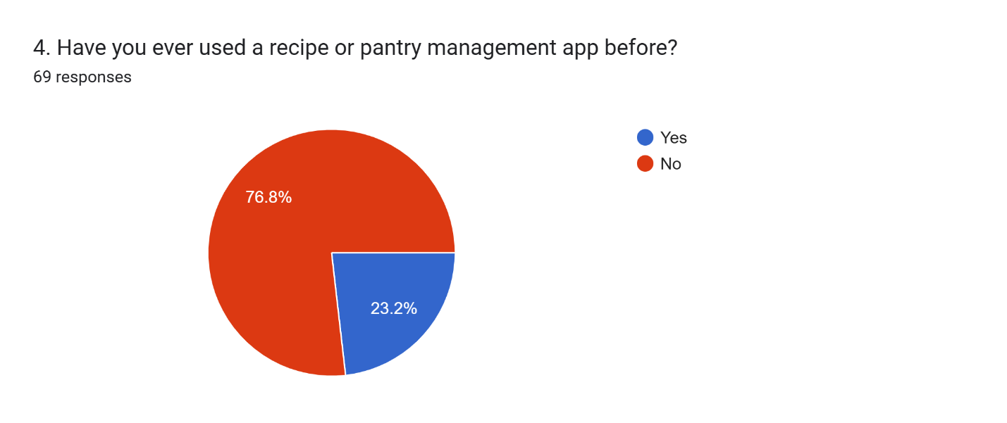

Figure : Pre-Survey Q4

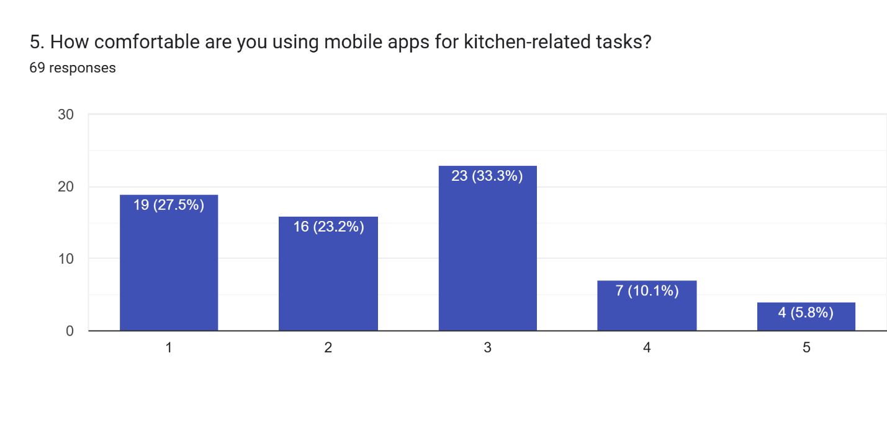

Figure :Pre-Survey Q5

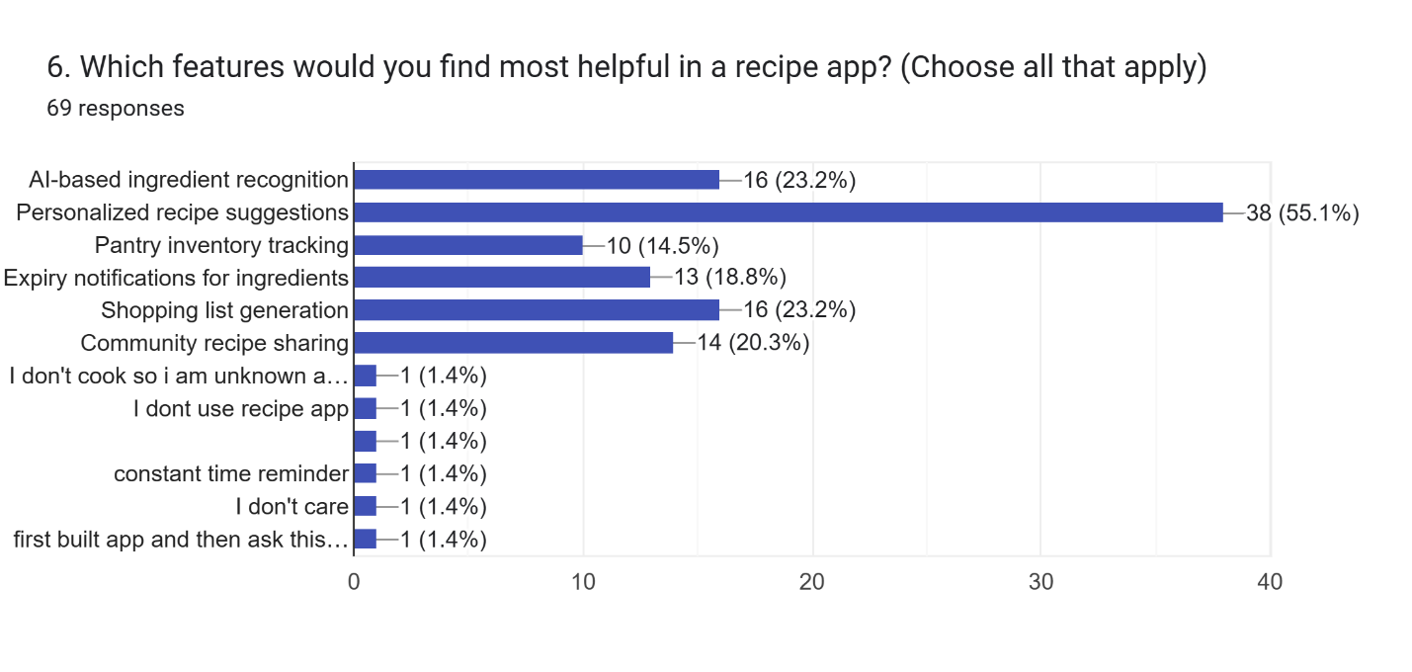

Figure : Pre-Survey Q6

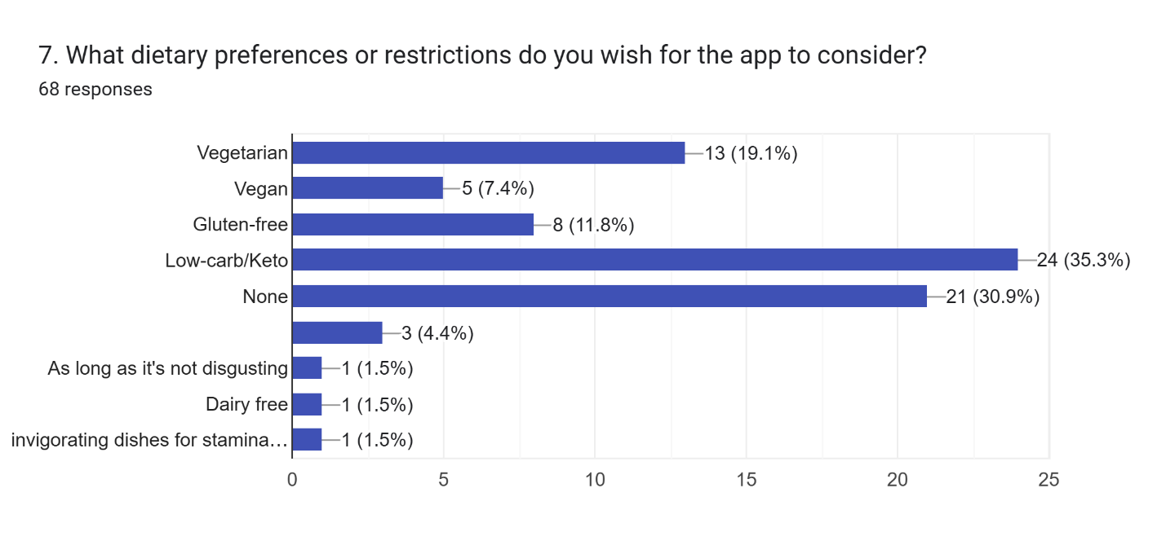

Figure : Pre-Survey Q7

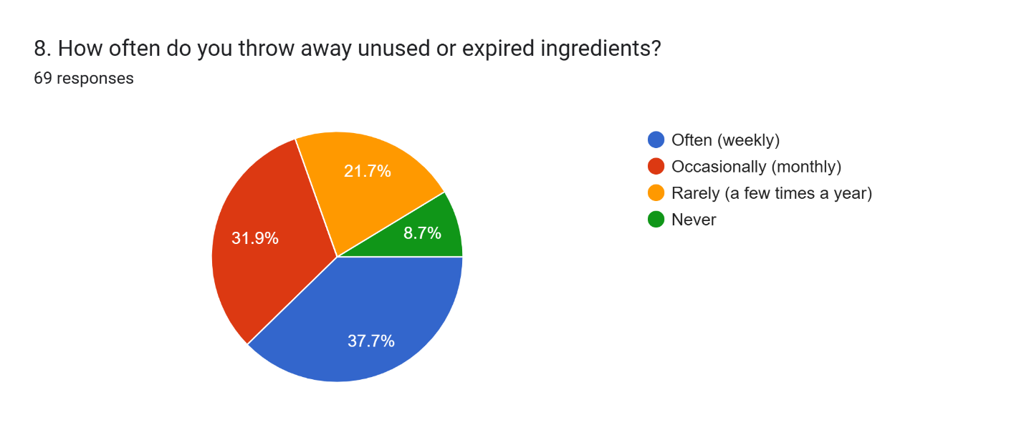

Figure : Pre-Survey Q8

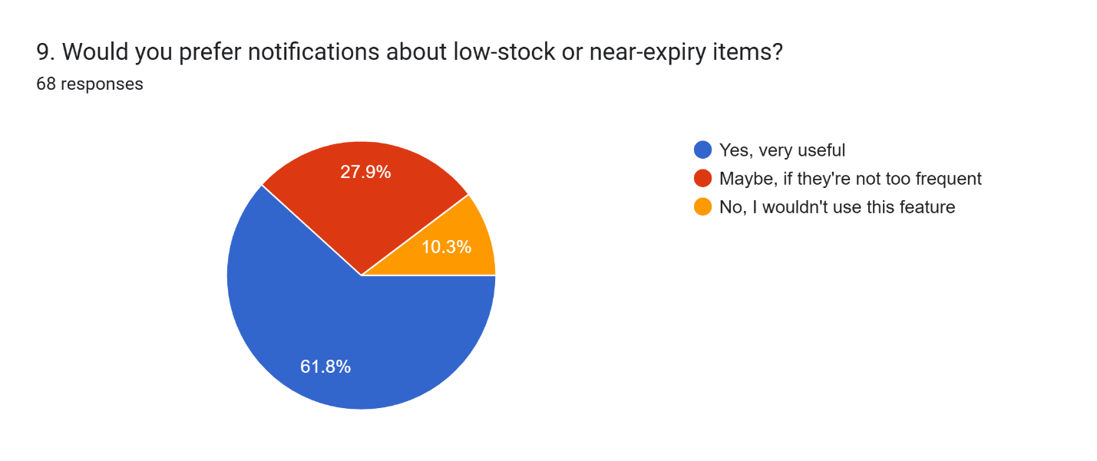

Figure : Pre-Survey Q9

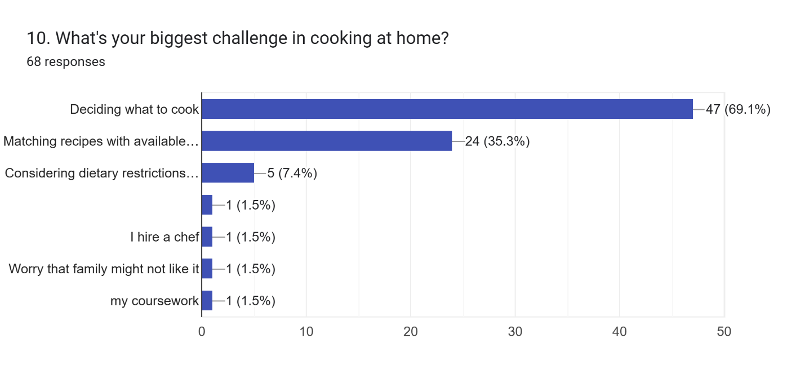

Figure : Pre-Survey Q10

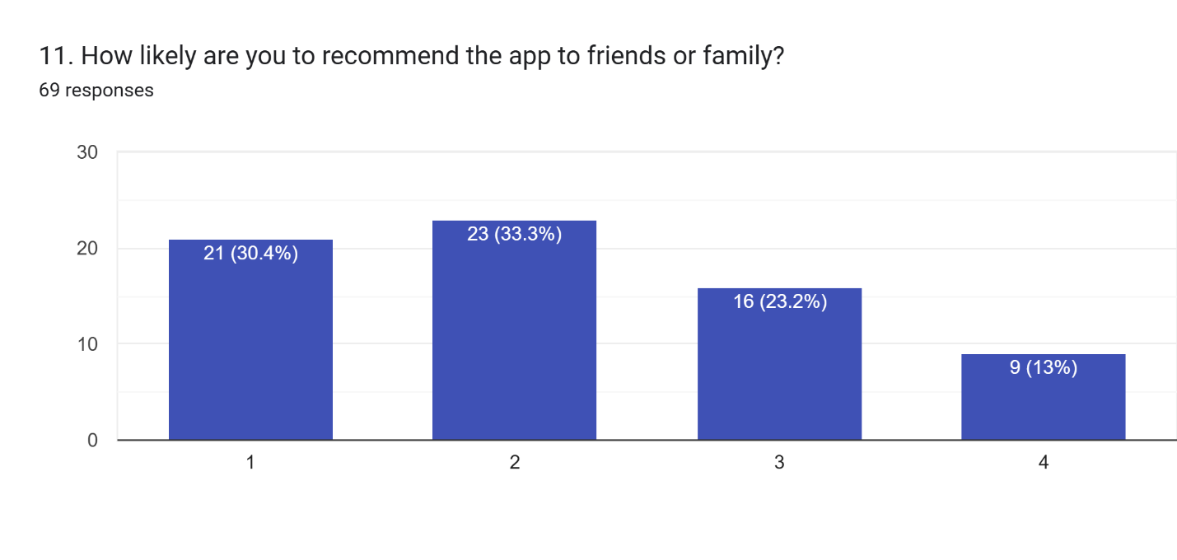

Figure : Pre-Survey Q11

## Appendix B: Post-Survey

### Post-Survey Form

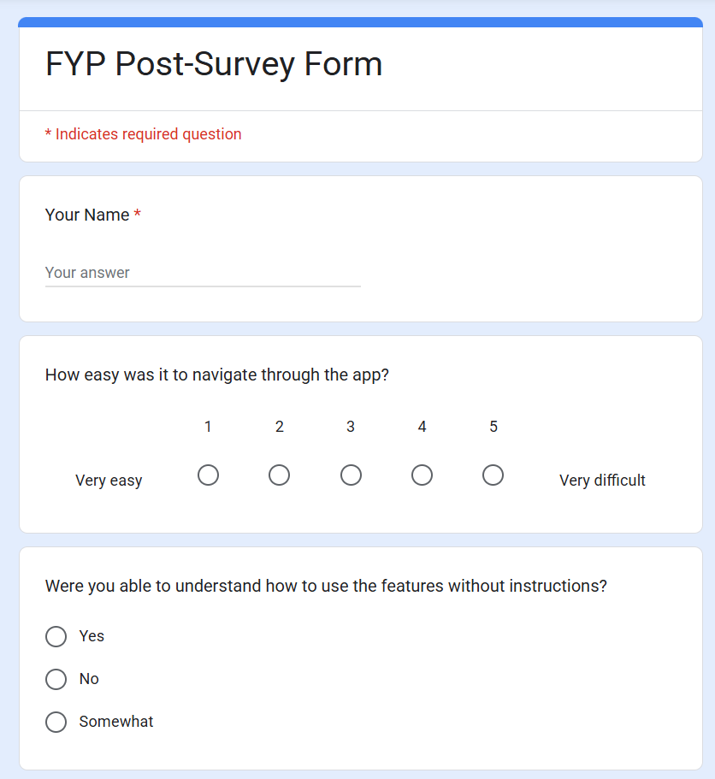

Figure : Post Survey Form pt.1

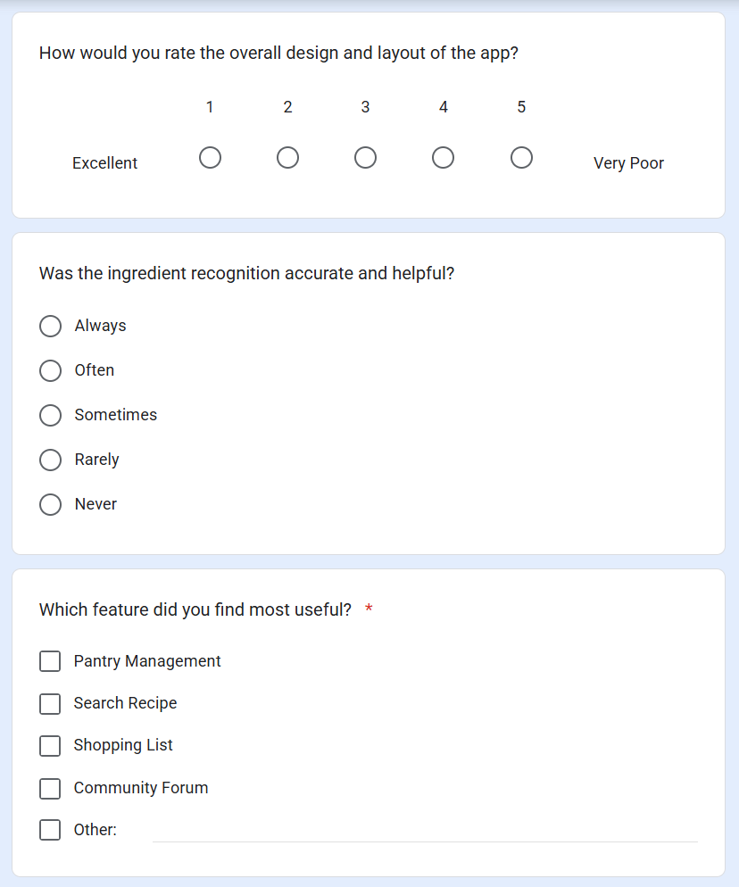

Figure : Post-Survey Form pt.2

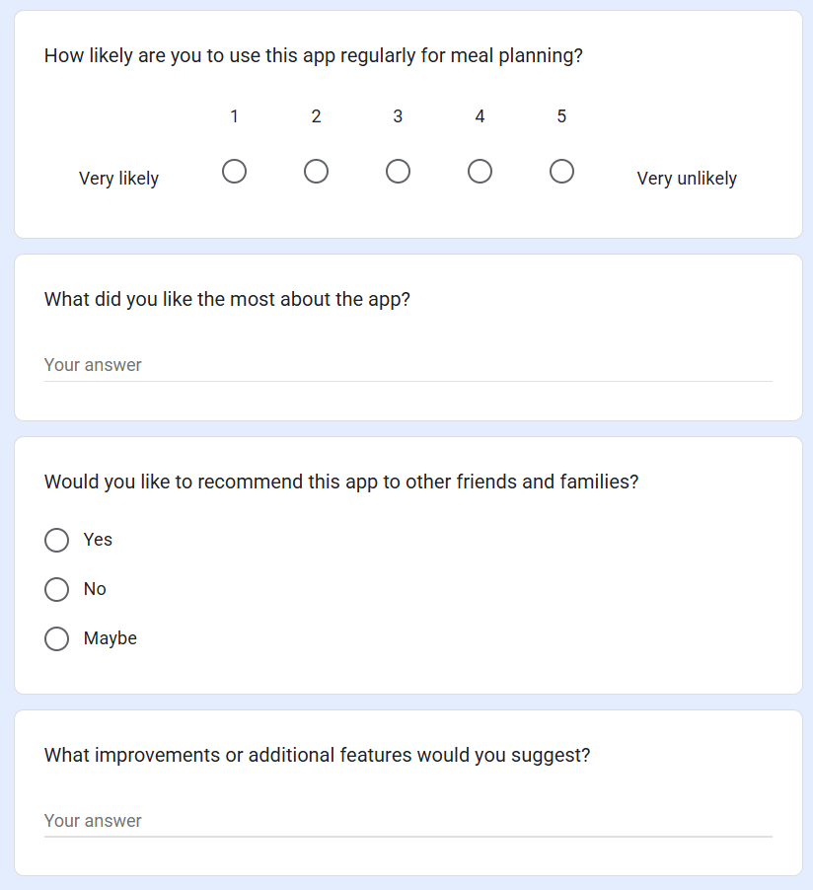

Figure : Post-Survey Form pt.3

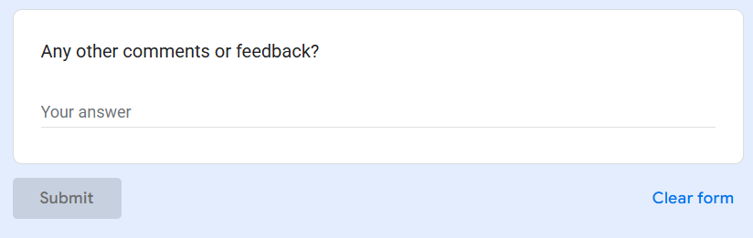

Figure : Post-Survey Form pt.4

### Sample of Filled Post-Survey Forms

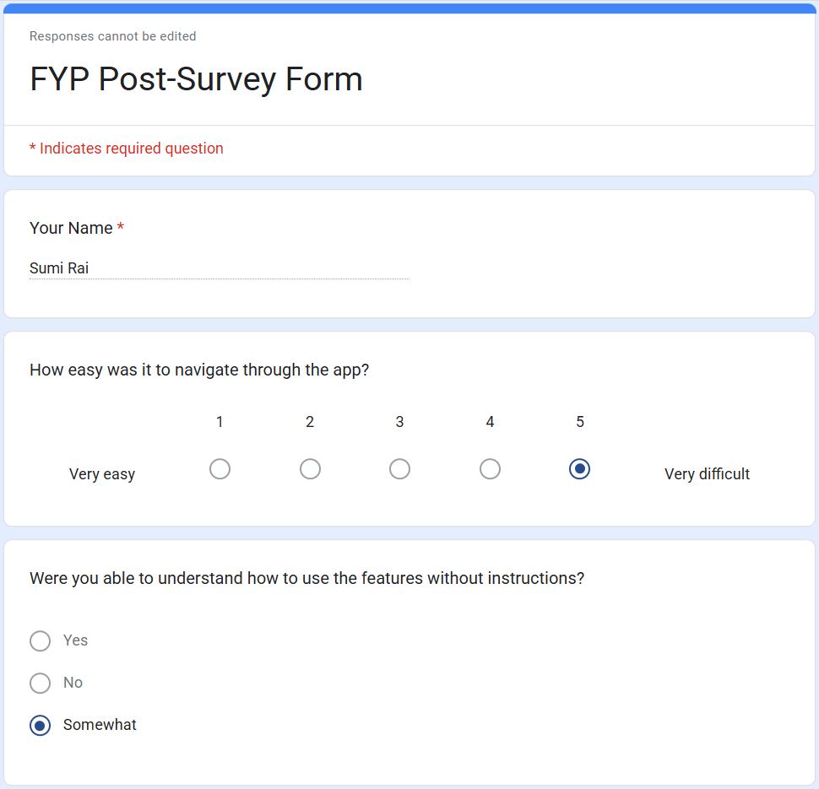

Figure : Post-Survey Smaple Form pt.1

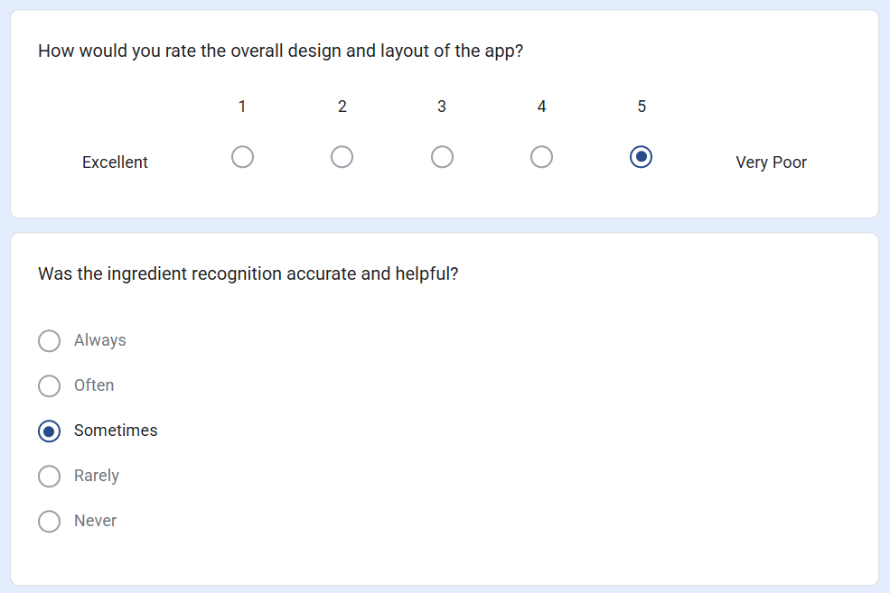

Figure : Post-Survey Sample Form pt.2

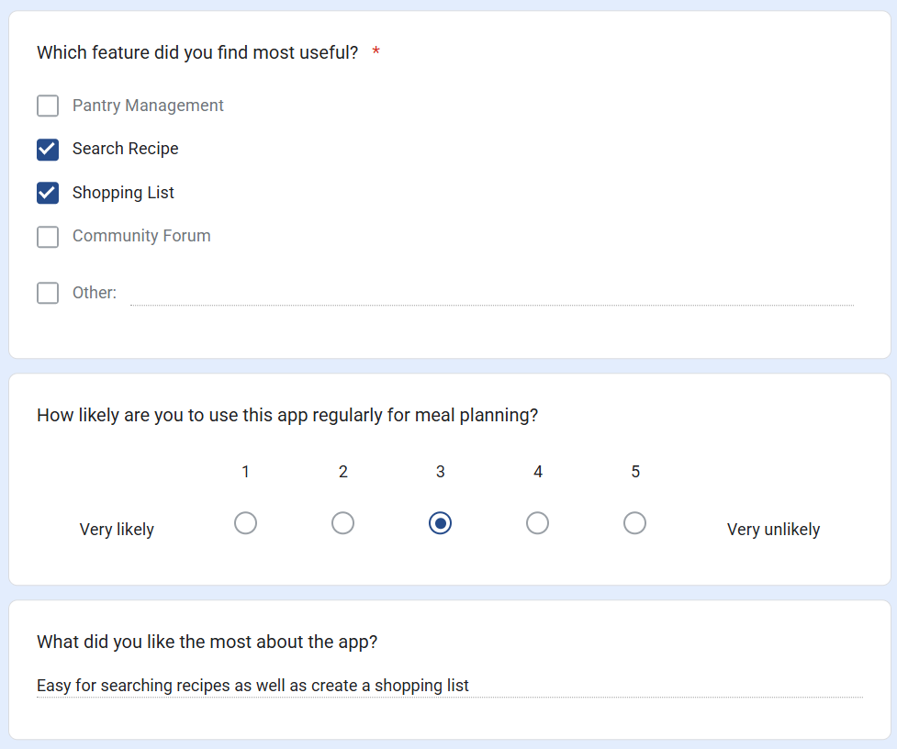

Figure : Post-Survey Sample Form pt.3

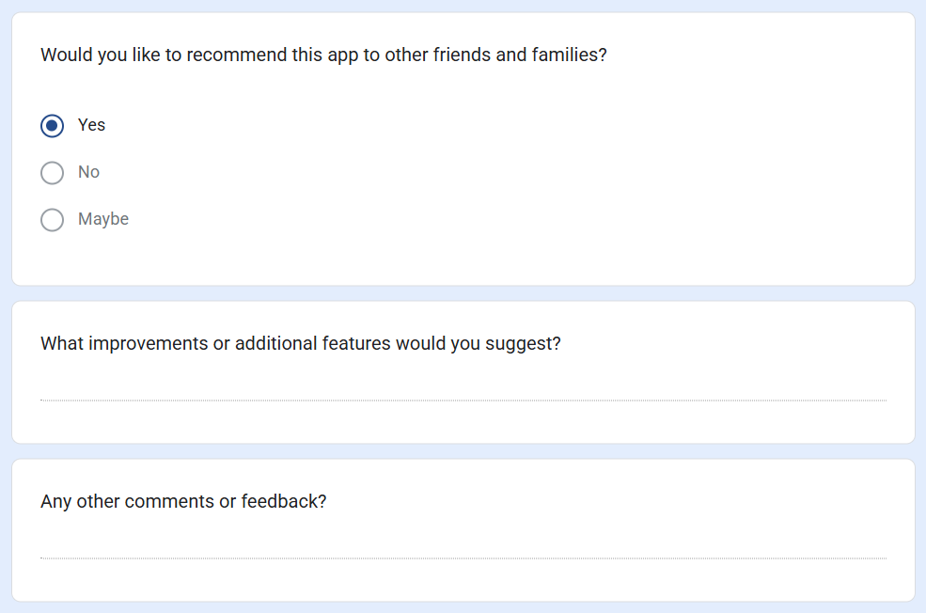

Figure : Post-Survey Sample Form pt.4

### Post-Survey Result

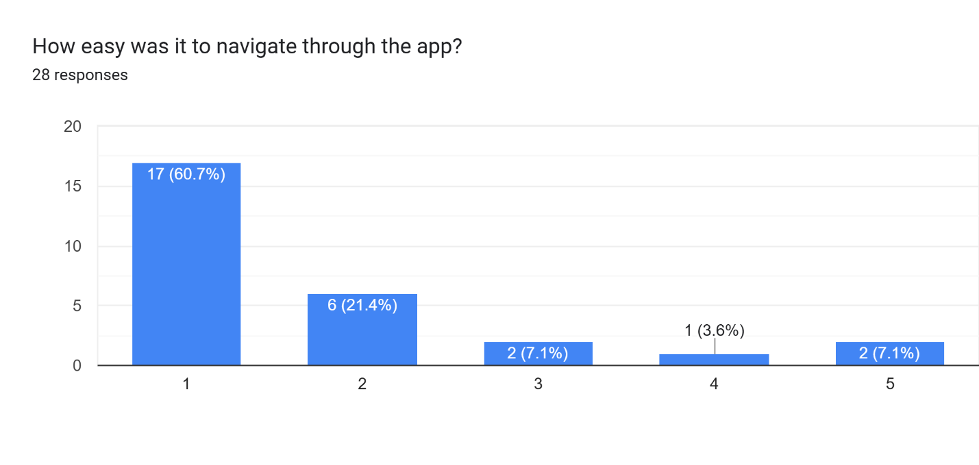

Figure :Post-Survey Q1

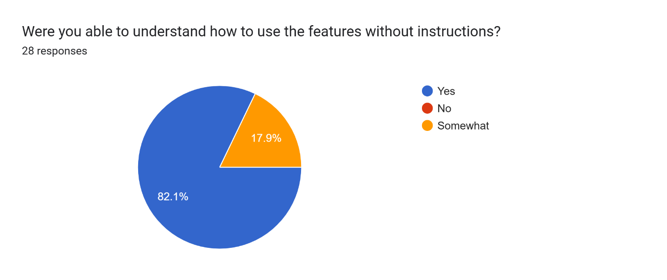

Figure : Post-Survey Q2

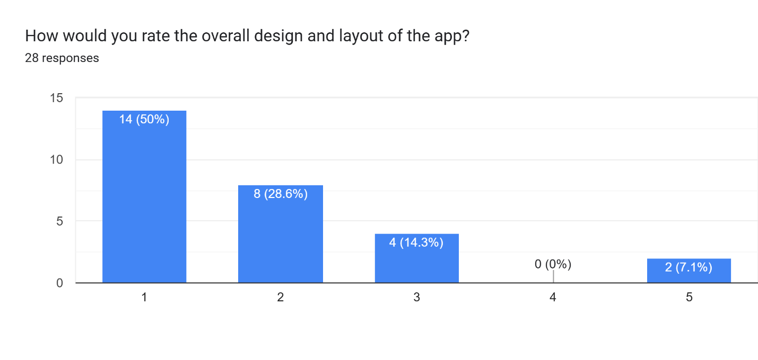

Figure : Post-Survey Q3

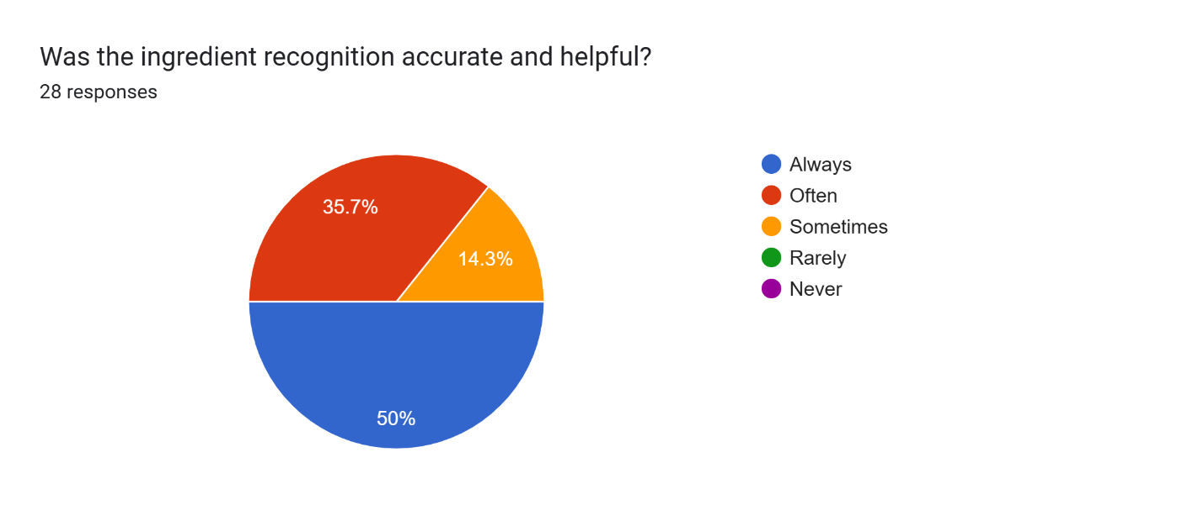

Figure : Post-Survey Q4

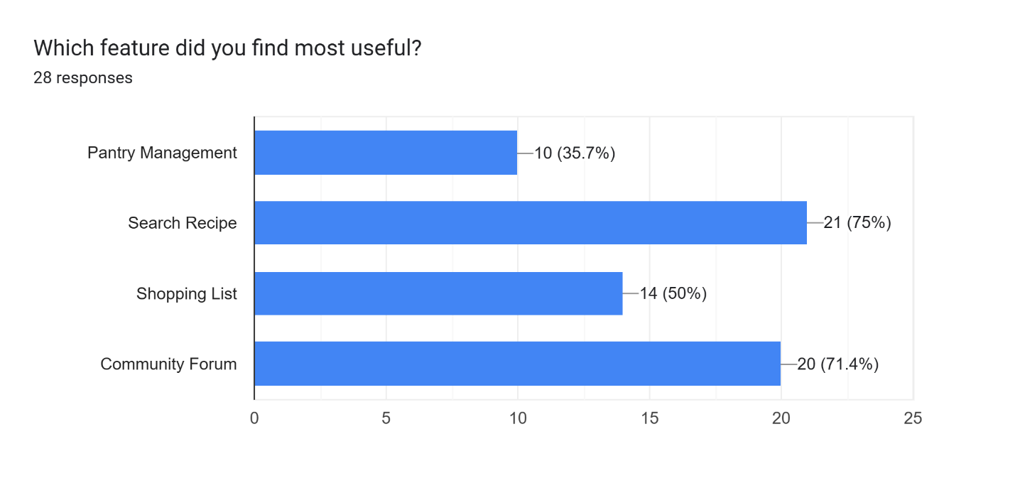

Figure : Post-Survey Q5

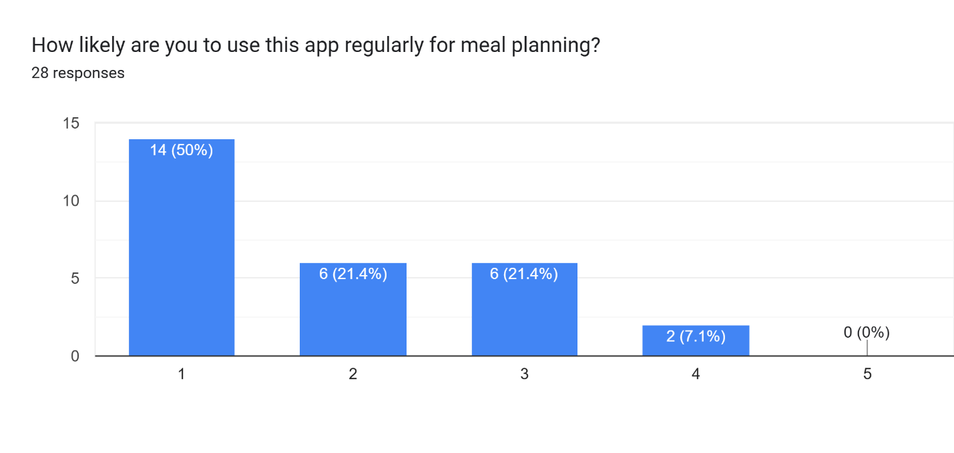

Figure : Post-Survey Q6

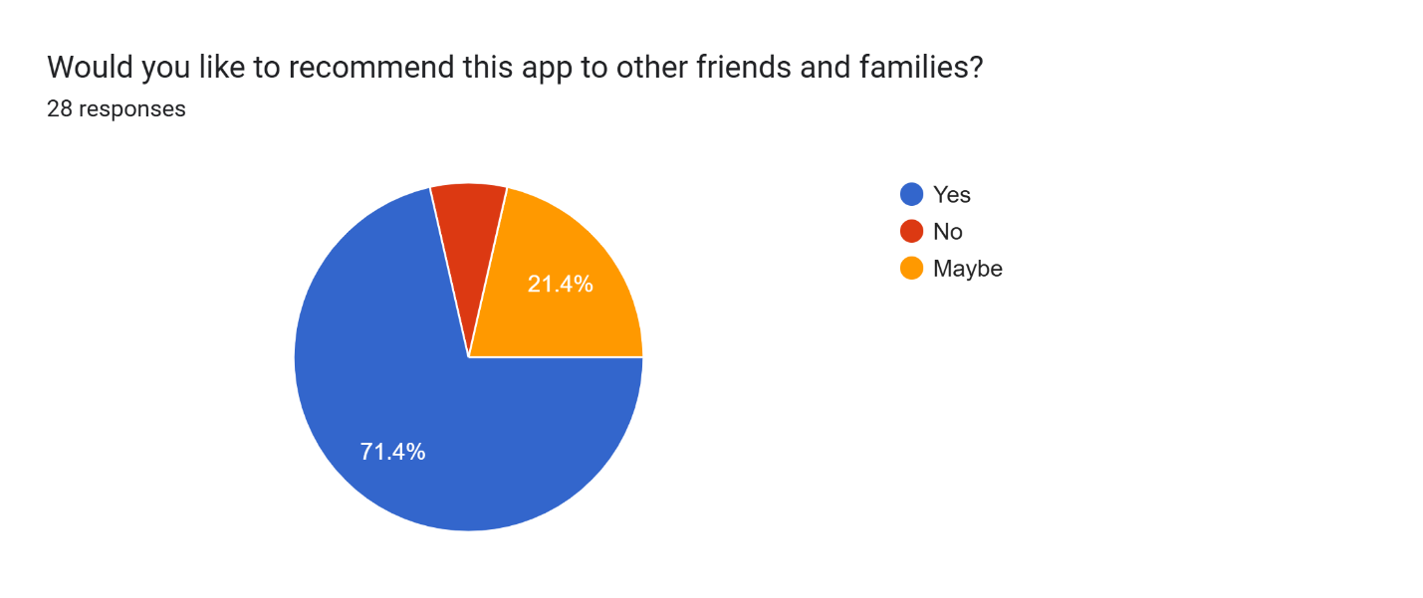

Figure : PosT-Survey Q7

## Appendix C: Sample Codes

### Sample Code of The UI

#### Login Page

#### Register Page

#### Home Page

#### Recipe Page

#### Create Post Page

#### Pantry Page

#### Profile Page

## Appendix D: Designs

### Gantt Chart

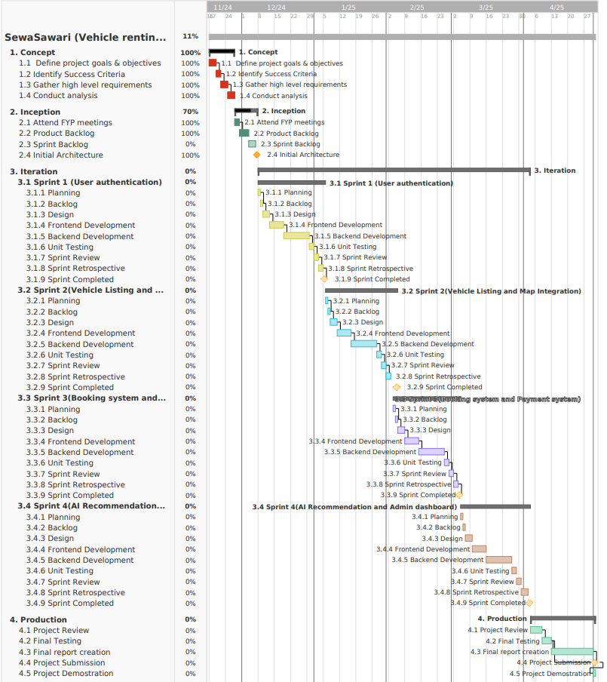

Figure : Gantt Chart

### Work Breakdown Structure

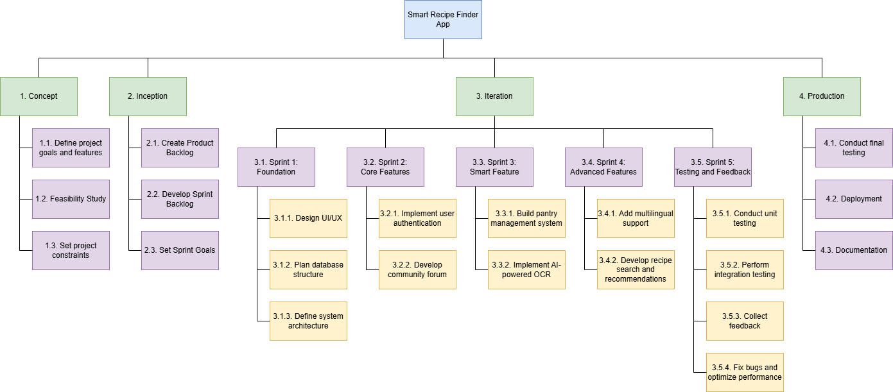

Figure : Work Break Structure

### Flowcharts

### Data Flow Diagrams

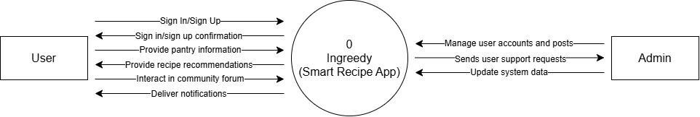

Figure : Data Flow Diagram

### Use Case

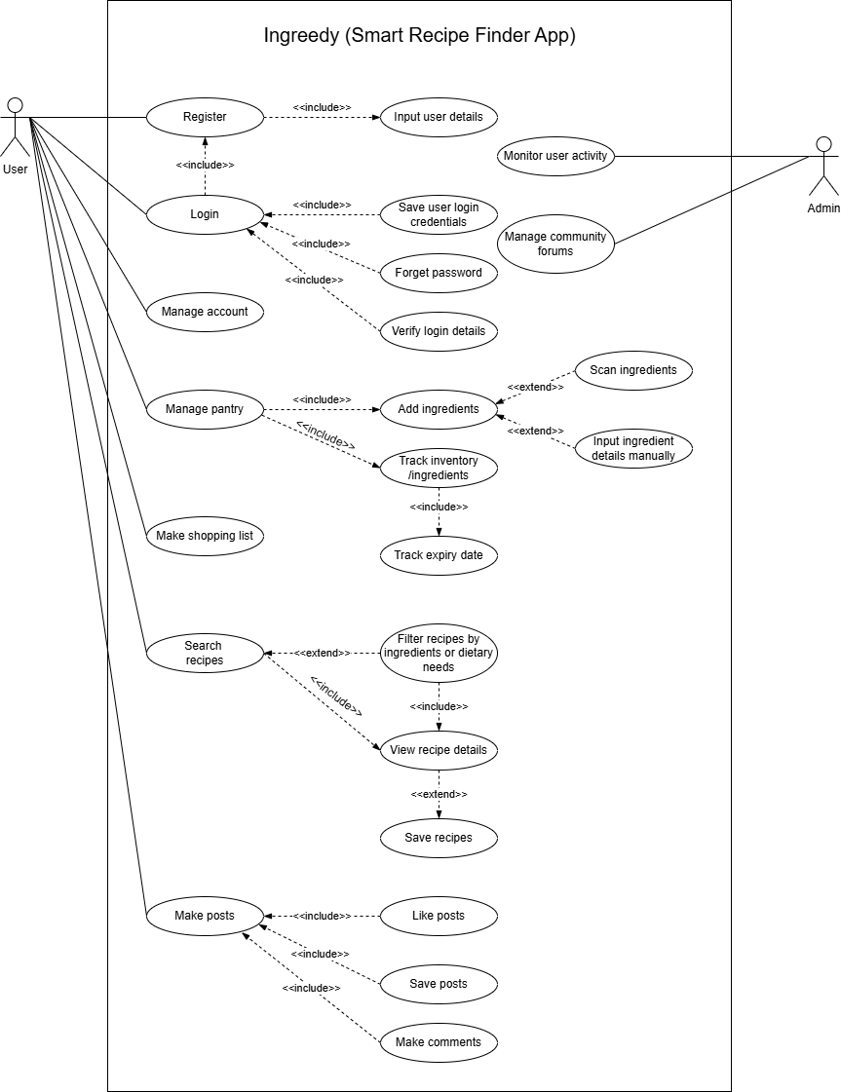

Figure : Use case diagram

### Wireframe

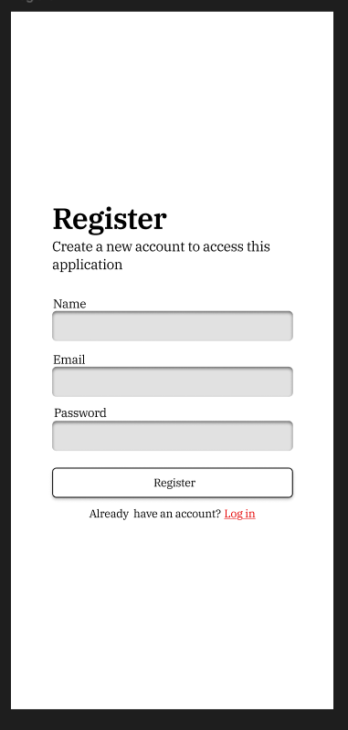

Figure : Register Page Wireframe

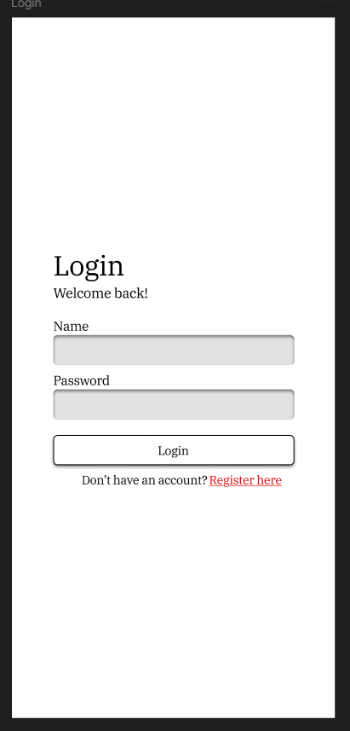

Figure : Login Page Wireframe

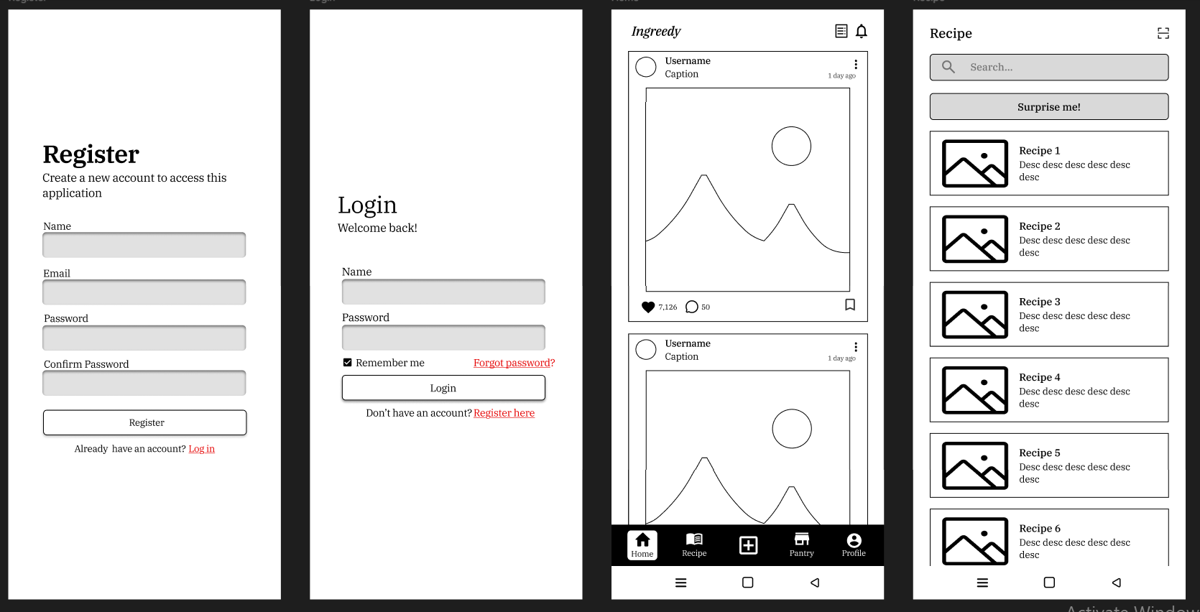

Figure : Home Page Wireframe



Figure : Recipe Page Wireframe

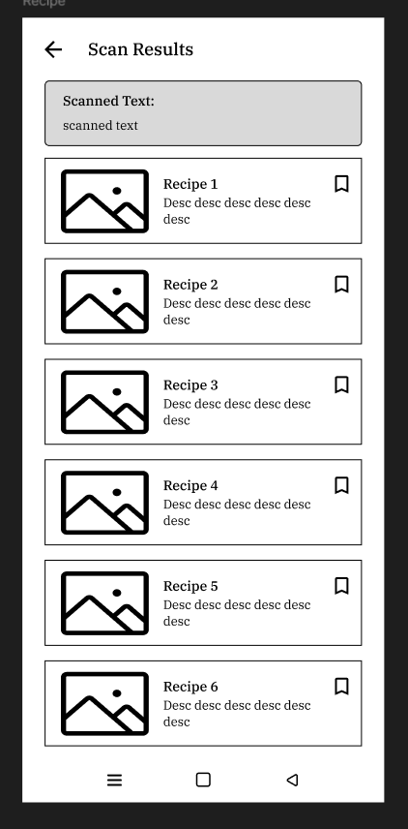

Figure : Scan result wireframe

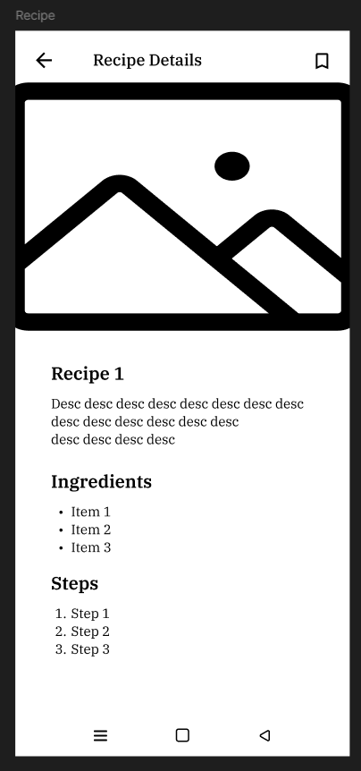

Figure : Recipe details wireframe

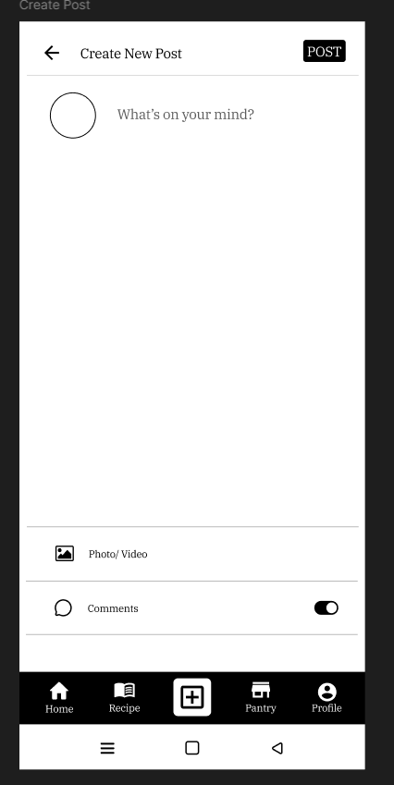

Figure : Create Post Wireframe

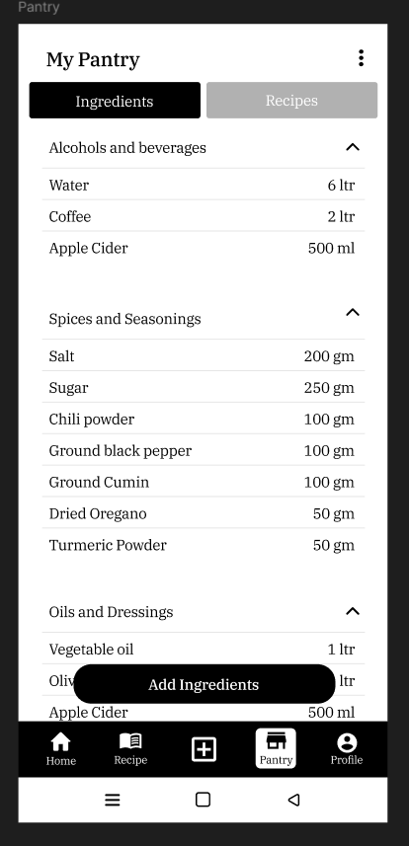

Figure : Pantry Page Wireframe

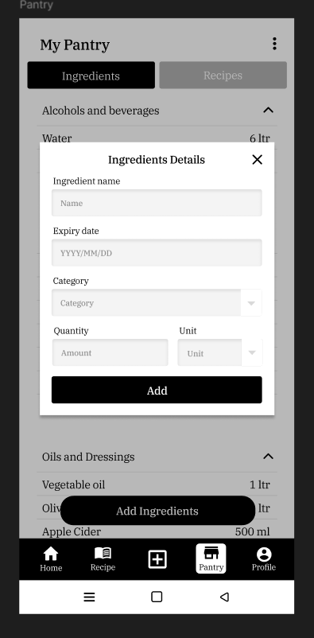

Figure : Add ingredient wireframe

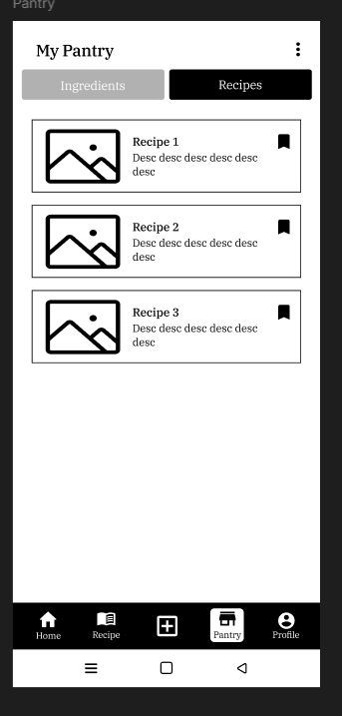

Figure : Saved recipes screen wireframe

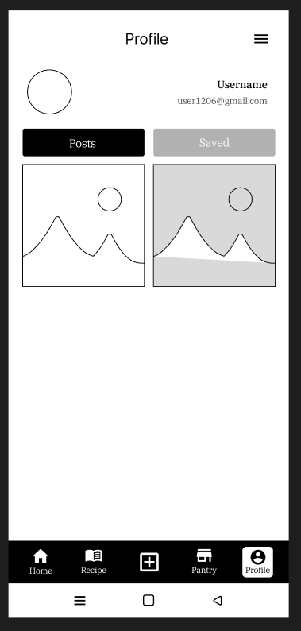

Figure : Profile Page Wireframe

## Appendix E: Screenshots of The System

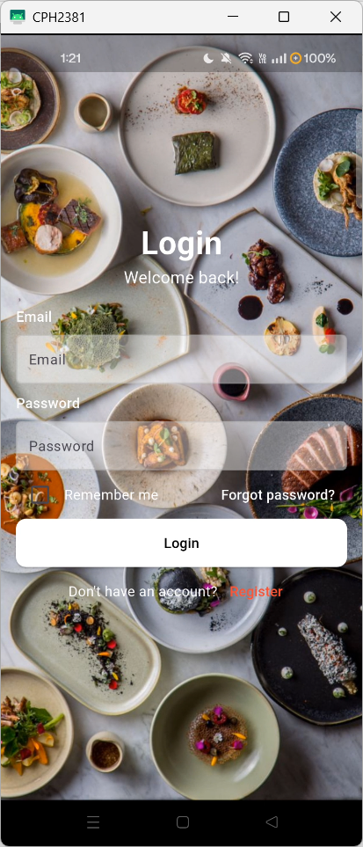

Figure : Login page screenshot

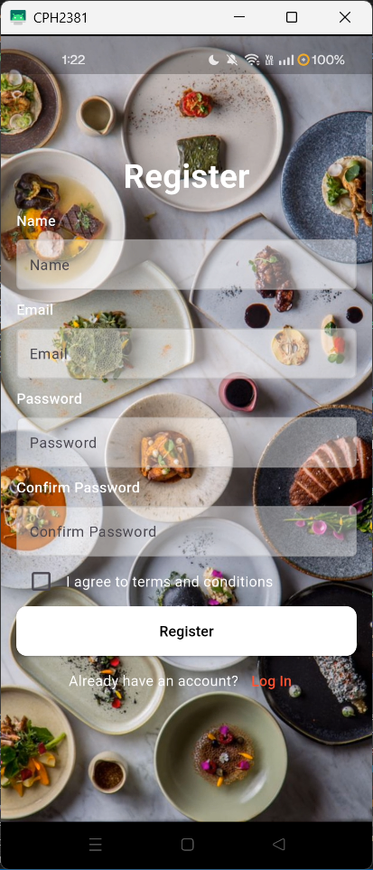

Figure : Register page screenshot

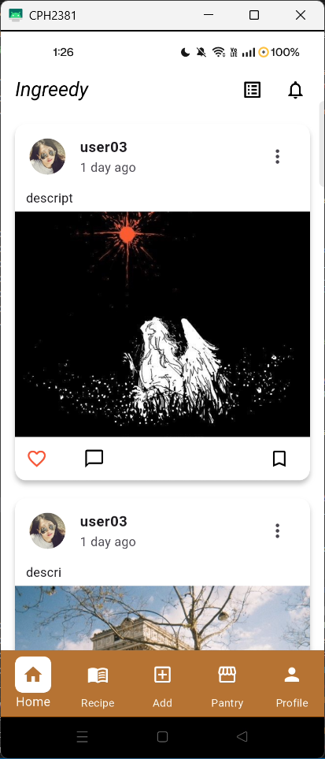

Figure : Home page screenshot

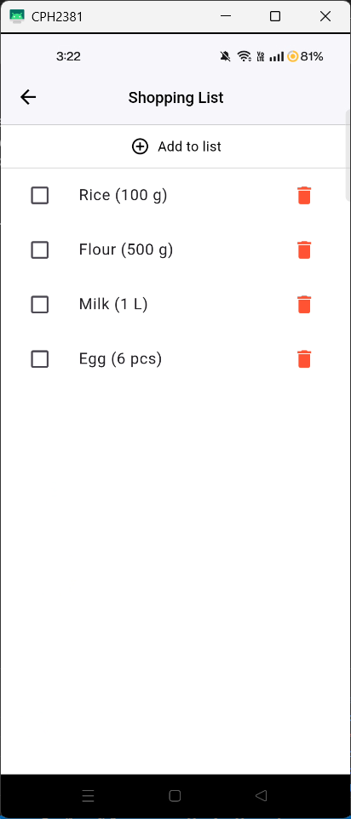

Figure : List page screenshot

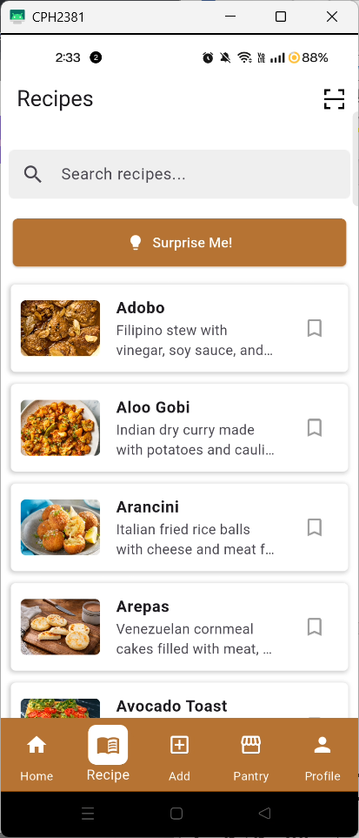

Figure : Recipes page screenshot

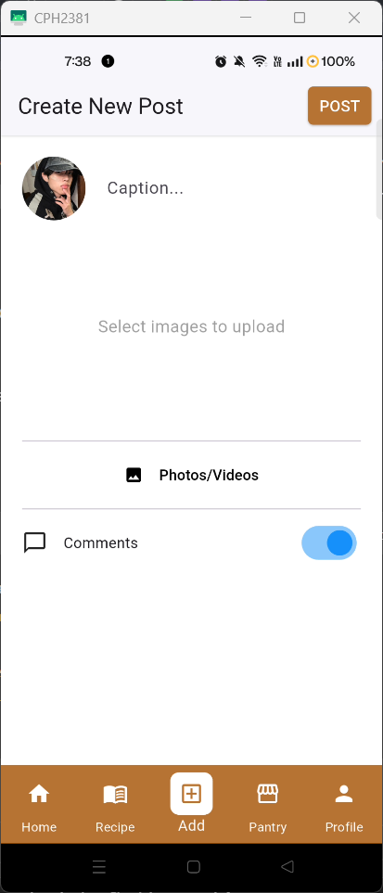

Figure : Create Post page screenshot

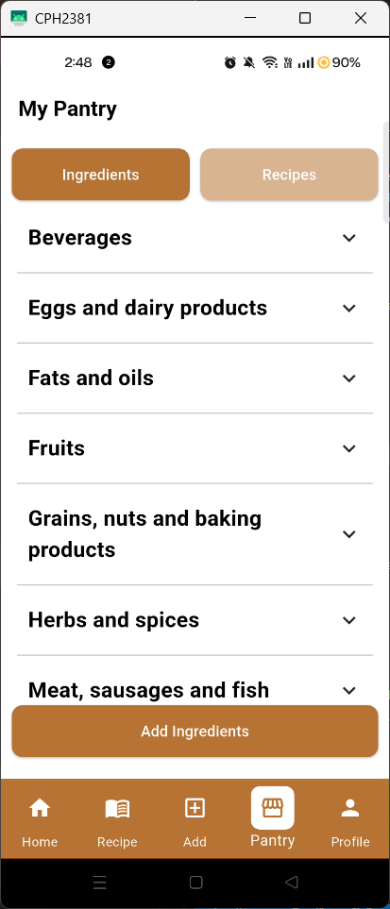

Figure : Pantry page screenshot

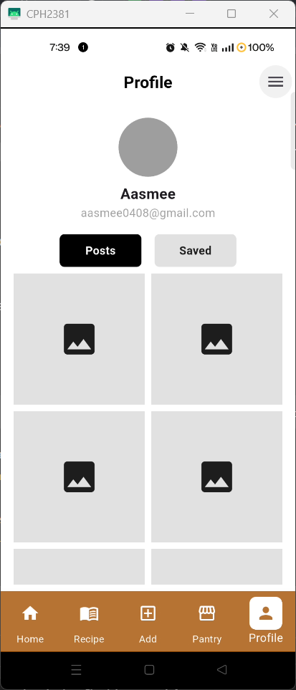

Figure : Profile page screenshot